University of Florida
Levin College of Law

Electronic Discovery
Course 6930 Section 1F02 2-credits

Course Syllabus

Course: Electronic Discovery
Spring Semester 2018

Class time: Mondays 1:00 – 3:00 PM, Room 285B

Office Hours: Tuesdays, 1:00 PM – 3:00 PM, or by appointment. I am also available for video conferences using Zoom outside my “brick and mortar” office hours. Just send me an email.

Course Description: Why You Should Take This Course: Electronic discovery and disclosure is a critical litigation and client management activity. Electronic discovery provides the vast majority of the evidence that determines case outcomes. This course will provide students with a working knowledge of the principal e-discovery issues frequently encountered in litigation, and the legal framework required to analyze and to resolve these e-discovery issues. This course will introduce you to industry standard electronic discovery tools, civil procedure rules governing electronic discovery, and case law interpreting the rules and e-discovery obligations and duties, and the multi-phase process of electronic discovery in civil litigation.

The exabytes of digital information streaming about us today are rich rivers of evidence that will help us find the truth and move us to do justice more swiftly, more economically and more honorably than ever before. It will require every litigator to master new skills and tools, and alter the approaches and attitudes we bring to the adversarial process. We must reinvent ourselves to master modern evidence or be content with a justice system that best serves the well-heeled and the corrupt. The path to justice is paved with competent evidence and trod by counsel competent in its use.

-Craig Ball, www.craigball.com

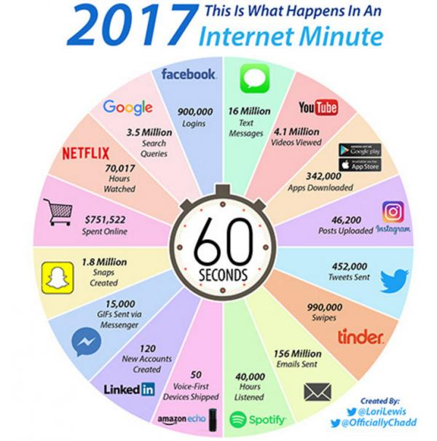

What We Will Cover in This Course and the Course Goals:

We will start the course with an elementary, basic introduction to computer technologies and computer files to build our basic language and foundation for the remainder of the course. Electronic discovery is about the vast array of computer generated information and evidence. Electronically stored information comes in a new information container –the computer file –that is different from paper and other information storage devices such as clay tablets. Electronically stored information is fragile. We will study and practice the preservation of electronically stored information and the legal duties associated with information preservation when litigation is reasonably anticipated. We must properly collect the ESI. We will study collection process and the legal requirement associated with proper collection. ESI must be exchanged with the opposition. We will study what needs to be negotiated with the opposition and how to do it. ESI discovery can be expensive. We will study and you will learn how to reduce costs and possibly shift some costs to the opposition. You will learn how to search, analyze and review data stores to identify and extract the relevant information, how to measure the success of searches, how to defend your searches, and how to compel the opposition to conduct meaningful searches of the information you have requested. We will explore the ways to produce and received ESI, and you will be able to demand from the opposition the production format that best fits your cases. Finally, we will explore how to seek and obtain sanctions for e-discovery mistakes and the loss of relevant information. You will emerge from this course able to direct, handle, and control electronic discovery processer in civil litigation in a legally defensible manner while obtaining, organizing and using data to your client’s best advantage.

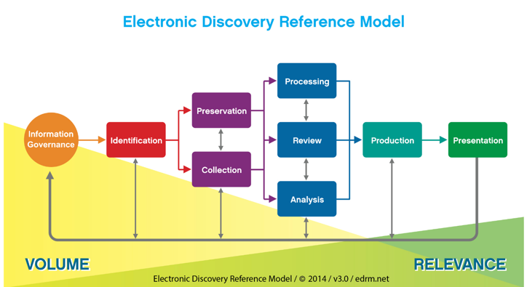

I’m not a Computer Geek. Is This Course Over My Head?

This course does not require specialized computer knowledge. The course will cover some very basic computer and network operations. If it is any comfort, I hold a Master’s Degree in European philosophy, which is just about the opposite of engineering computer circuits.

Will I Need to Become an Expert in Technology?

The short answer is “No.” However, you will need to make a commitment to learn a new “technical vocabulary” and understanding some basic technology concepts so you can knowledgeably “walking the walk” while “talking the talk.” This will not be difficult, and this course will provide all you will need. I think you will find it fun to understand how a computer works. Few people really know this--amaze your friends!

Will I Need to Master Complicated E-Discovery Software?

Electronically stored information is binary data. Data must be handled by software. For example, you can’t edit a Word document without a computer and word processing software. Similarly, we need software to effectively do electronic discovery. But we are not in the dark ages. Contemporary e-discovery software is easy to use. Getting familiar with a few e-discovery tools that we will use in this course will help you understand the challenges of electronic discovery and how the law has evolved. Familiarity with e-discovery software will give you a practice jump start.

How Much Reading and Work Will This Course Require?

The American Bar Association requires two hours of outside work for each hour of class. This course involves a number of activities beyond reading our text. I have endeavored to make sure that the total time demanded by this course does not exceed the ABA requirements. I have reduced the normal 30 pages of reading per week when there are additional assignments.

Who Is Your Professor?

I joined the UF Law faculty as a time full Legal Skills Professor after 30 years practicing complex civil litigation with Holland & Knight in Miami and Tampa and Quarles & Brady in Tampa. Electronic discovery changed my career when I realized it was the new, rich, contemporary format of information that would win cases for my clients. Prior to leaving the practice of law, I was a UF adjunct professor for 10 years and established the UF E-Discovery Project.

While I consider myself a “native” Floridian having spent my entire adult life in Florida, I am originally from Philadelphia. I earned my undergraduate degree from Lehigh University in Bethlehem, Pennsylvania, and a MA in philosophy from Washington University in St. Louis, Mo. I graduated from UF Law in 1983.

Here are a few links where you can learn more about me.

https://www.law.ufl.edu/faculty/william-hamilton
https://www.law.ufl.edu/areas-of-study/institutes/icair
https://www.linkedin.com/in/williamfhamilton
http://www.quarles.com/william-bill-hamilton/

I am married to Cynthia Tejcek. Cindy graduated from Loyola in Chicago with a BS in mathematics. She holds an MBA from Kellogg. We meet when she was the chief information officer of the ABA. Yes, we are big Cubs baseball fans.

We have a son who just finished earning his BA in mathematics at the University of West Florida and is now commissioned as an Army officer.

We have another son studying nursing in Tampa.

And, I’m very pleased that our daughter is a junior at UF studying criminology and law. Go Gators

How Can You Get In Touch with me?

I want to hear from you. Send me an email, call, or text.

Email | Telephone | Text | Office
hamiltonw@law.ufl.edu | 480.993.8777 | 480.993.8777 | 342 Holland: Tuesdays 1-3

Please let me know If you have something to share with me – an inspiration, a new thought, a frustration, or concern. Let have coffee together in the commons.

Zoom is one of my favorite video conferencing tools. We can have a face-to-face video conference any time (even on tablets and smartphones). It is as simple as Facebook.

Zoom | SKYPE
https://zoom.us/j/5410389684 | william.hamilton.1120

Teaching Philosophy and Instructional Methods: This course has a practical orientation. While you will learn the Federal and Florida Rules of Civil procedure governing electronic discovery and read cases. But the emphasis of the course is on solving the practical electronic discovery problems that arise in practice. You will learn to act like an e-discovery lawyer in this class. We will have lots of class discussions, practical exercises, and periodic law stakes quizzes.

You may wish to review literature on experiential learning. My teaching philosophy is in large part captured in Make It Stick: The Science of Successful Learning by Peter C. Brown.

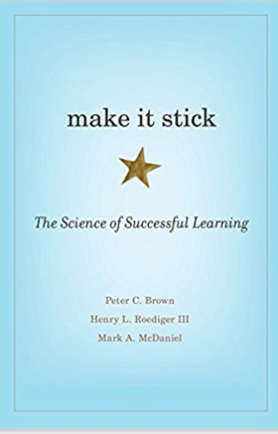

This course is designed to introduce students to a variety of career paths involving e-discovery skills. I recommend the book
“Designing Your Life: How to Build a Well-Lived Joyful Life,” by Burnett and Evans, Alfred A. Knopf (2016), for helpful strategies to find career directions that will work for you.

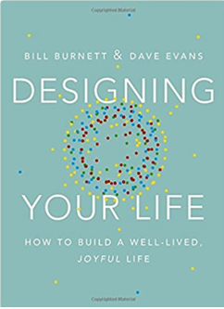

You are expected to attend all the class sessions. Each week students will be asked to read certain basic cases and text. Approximately every three weeks there will be an in-class 20-minute spot quiz to give you and me some feedback on how we are doing.

You will also complete Harvester, Nuix and Catalyst assignments.
Harvester and Nuix are very popular, highly regarding e-discovery software tools. We host Harvester and Nuix on UF Apps.

The Catalyst Student Practicum involves watching videos, completing exercises, and taking short quizzes. Catalyst is an award-winning e-discovery software product.. Each student will have a specially issued Catalyst ID and password. The Catalyst Student Practicum may be taken until passed. Completion of the program entitles the student to a Catalyst Student Practicum Certificate. The class sessions will typically involve practical individual and group exercises.

Examination and Grading Policy: The total points that may be earned in the class are 1090. While the course grade distribution usually reflects the usual structure of A = 100 – 90%, B = 89% - 80%, etc., student should keep in mind that the final grade will reflect class rank not points obtained. For example, a numerical grade average of 92% earned on various exercises and assignment during the course may not reflect the final grade when combined with the score earned on the final examination. Early assignment scores should not establish an expectation of a similar final grade.

Is this Course Graded on a Curve?

This course is graded on a curve. Fortunately, it is not a classic bell curve!
I am provided a curved grade range by the Registrar and my class grade average must be within that range. In past semesters, my grade point average has been around 3.25.

Points may be earned as follows:

1. Final examination: 560 points.

There will be a 3-hour “take-home” open book examination composed of 3-4 fact patterns. The final exam may be taken at any time during the finals period. The student Honor Code applies. The 3-hour examination will be graded on the following rubric:

- 25 points: Identification of e-discovery issues presented by the scenario,
- 25 points: Analysis of the e-discovery issues presented by the scenario,
- 25 points: Application of case law and civil procedure rules to the issues presented by the scenario,
- 25 points: Resolution of the issues presented by the scenario,
- 25 points: Felicity, conciseness, and richness of the written expression.

The examination will be administered by the Registrar’s office using ExamSoft. The examination will include materials and topics discussed in class in addition to the readings. Each of the scenarios on the final examination will ask you to adopt a role such as retained plaintiff or defense counsel, magistrate judge, or client and respond to the factual pattern from that perspective.

2. Class Attendance and Participation: 140 points (14 points per class).

Class attendance and participation is expected. Each class is worth 10 points. Class participation will be evaluated on the following rubric:

- Asking and answering questions that illuminate e-discovery issues,
- Asking and answering questions that enrich the class dialogue and advance the classes understanding of the issues,
- Participating in the class dialogue,
- Demonstrating class preparation.

If you cannot attend a class for personal or professional reasons please must notify in advance in advance as a professional courtesy. I recognize that you may have legitimate and compelling personal and professional requirements that may cause a class absence. Each student has two “free” excused absences. After four absences, you will lose class attendance points for each class missed, absent extraordinary and exception circumstances. If you miss a class and would like to review the class content and materials, please contact me. I am happy to review the materials with you.

3. Low Stakes Check-Ups: 120 points.

There will be three 20-minute in class “check-ups” that will consist of multiple choice, true/false, and matching or short answer questions. Each of the checkups will be worth 40 points. The Check-Ups are designed to give you feedback and a reality check on how well you understand the course materials presented so far and to provide feedback to me on what course areas and topics may need additional coverage

3. Catalyst Student Practicum: 180 points

You will take a three-part Catalyst Student Practicum course during Modules 7, 8, and 10 that culminates in a completion Certificate from Catalyst. Each part of the Practicum consists of (i) a series of videos on Catalyst search software, (ii) a series of exercises, and (iii) a short 10-question “quiz” on the materials. I am available for voluntary individual and group tutorials on the Catalyst software. I recognize that professional and personal demands may make completing the Catalyst Exercises and Quizzes with the time allotted. Please let me know prior to the due date if you need an enlargement. You must obtain an 80% on each phase of the Practicum to continue to the next phase. There are three phases. A score of 80% must be earned on each phase. The Quizzes however may be taken repeatedly until an 80% is obtained. You may also continue to take the Quizzes to move their scores to 90% or 100%.

5. Nuix Exercise: 30 points.

You will upload and analyze data on the Nuix e-discovery platform. The Nuix Workstation is available on the University Apps page. Directions will be provided.

6. Harvester Exercise: 30 points.

You will do a legally defensible data collection using the Harvester e-discovery software. Harvester is available on the University Apps page. Directions will be provided.

7. Follow the University of Florida Levin College of Law E-Discovery Project on social media: 30 points.

The UF Law E-Discovery Project operates a Facebook page, Twitter feed, and YouTube channel. You are required to follow these social media sites for the duration of the course to keep up with contemporary e-discovery industry activities bearing on class materials and lessons and providing additional richness and context. Students may use existing social media accounts or set up social media accounts for the course using a new Google address.

8. Watch the movie The Decade of Discovery. 30 points.

You will be required to watch the 1-hour movie The Decade of Discovery and file a certification that you diligently watched the movie.

Class Cancellations

Occasionally, I may have to reschedule a class due to professional demands. If this happens, I may record video lectures for the class to watch or conduct the class remotely by Zoom.

Are Smartphones and Laptops Permitted in the Classroom?

You may use laptops in class to take notes. I will turn my phone off when I come to class. Please do the same. Please restrict the use of your laptop to taking notes. Do not visit social media websites, texting, or emailing. Keep your browser closed to avoid temptation. Do not abuse this privilege. I expect your attention in class. Nothing life changing will happen while you are offline in class.

What Notes Should I Take in Class?

I recommended that you do not take word-for-word literal notes with your computer. This is not a court reporting class! Instead, think about what is happening in class and record the key ideas. Actually, handwriting your notes is better for you then typing notes. Check out this article: Note-Taking: Writing vs. Typing Notes. Beyond that, manual note taking is an important legal skill. You will need to learn to take good witness interview notes, deposition notes, and trial notes. A computer will not always be available or good to use.

What Happens if I am Late Turning in an Assignment?

Every assignment is on Canvas. Canvas provides three for each assignment: a date when the assignment is open, a date when the assignment is due, and a date when the assignment is closed. Each assignment opens at 9:00 Monday of the week it is due. All assignments are due the following Friday at 5:00 PM. The assignment, however, stays open on Canvas for two additional weeks after the due date. If the assignment is turned in during the first week after the due date, the available points on the assignment are reduced by 10%. If the assignment is turned in during the second week after the due date, an additional 10% of the available points become unavailable. For example, if the assignment is worth 30 points and you turn it in two weeks late, you can only earn a maximum 24 points on the assignment. Absent extraordinary circumstances I will not accept an assignment more than two weeks late, and you will earn zero points for the assignment.

Assigned Text:

Electronic Discovery and Digital Evidence, Scheindlin and Capra, West Publishing, Third Edition, 2015 (referred to herein as (“S&C”)

Recommended Secondary Resources:

LexisNexis Practice Guide Florida E-Discovery and Evidence, Artigliere and Hamilton http://www.lexisnexis.com/store/catalog/booktemplate/productdetail.jsp?pageName=relatedProducts&prodId=prod14330392. (free online access for UF students).

Project Management in Electronic Discovery, M. Quartararo (2016)
Available on Amazon (Kindle version $17.99)

Weekly Class Objectives, Schedule, and Assignments:

The specific weekly lesson, objectives, reading materials, assignments, and exercises are on the course’s Canvas page.

I reserve the right to make reasonable adjustments and modifications to the course weekly schedule as required by the pace and progress of the class.

Academic Honesty and Integrity

Academic honesty and integrity are fundamental values of the University community. You should be sure that you understand the UF Student Honor Code at http://www.dso.ufl.edu/students.php.

Statement related to accommodations for students with disabilities

Students requesting accommodation for disabilities must first register with the Dean of Students Office (http://www.dso.ufl.edu/drc/). The Dean of Students Office will provide documentation to the student who must then provide this documentation to me when requesting accommodation. You must submit this documentation prior to submitting assignments or taking the quizzes or exams. Accommodations are not retroactive, therefore, students should contact the office as soon as possible in the term for which they are seeking accommodations.

Information on UF Law grading policies

Grade Points Grade Point Grade Point
A (Excellent) 4.0 C+ 2.33 D- 0.67
A- 3.67 C (Satisfactory) 2.00 E (Failure) 0.0
B+ 3.33 C- 1.67
B (Good) 3.00 D+ 1.33
B- 2.67 D (Poor) 1.00

The law school grading policy is available at: http://www.law.ufl.edu/student-affairs/current-students/academic-policies#9.

Student Course Evaluations
You can provide feedback on the quality of instruction in this course by completing online evaluations at https://evaluations.ufl.edu. Evaluations are typically open during the last two or three weeks of the semester, but you will receive notice of the specific times when they are open. Summary results of these assessments are available to you at https://evaluations.ufl.edu/results/

Getting help:
For issues with technical difficulties for E-learning in Canvas, please contact the UF Help Desk at:

● Learning-support@ufl.edu
● (352) 392-HELP - select option 2
● https://lss.at.ufl.edu/help.shtml

Other resources are available at http://www.distance.ufl.edu/getting-help for:
- Counseling and Wellness resources
- Disability resources
- Resources for handling student concerns and complaints
- Library Help Desk support

Disclaimer: This syllabus represents the current course plans and objectives. As the semester proceeds, these plans may be changed to enhance the class learning experience. Such changes, communicated clearly, are not unusual and should be expected.

