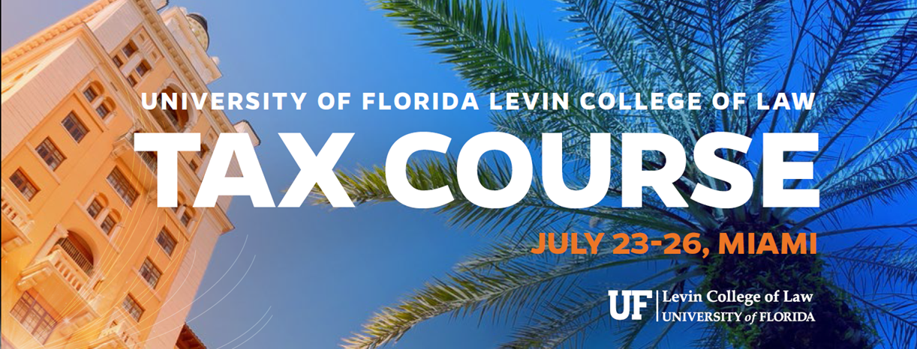
2017 was a milestone year for tax policy developments in the United States. On December 22, President Trump signed into law The Act to provide for reconciliation pursuant to titles II and V of the concurrent resolution on the budget for fiscal year 2018, Pub.L. 115–97 (informally known as the Tax Cuts & Jobs Act, or TCJA). This law has major impacts for cross-border investment, impacting both non-U.S. persons investing into the United States, and U.S. persons investing overseas.

Guidance interpreting the new law remains to be written, but in the interim taxpayers need to plan their affairs. How to do so given the significant changes, and in the absence of much concrete guidance from the IRS and Treasury?

The University of Florida Levin College of Law has organized this special summer tax course to help make sense of the new law. It brings together a group of leading practitioners with deep international tax expertise who can bring unique insights to the different tax provisions, as well as members of the faculty of UF law school.

We look forward to spending the week with you and learning with you, on the path to becoming true experts in the U.S. international tax provisions in 2018 and beyond.

Logistical information

The course is being held at UF’s Coral Gables campus, at 1 Alhambra Plaza, Coral Gables.

Breakfast and lunch will be served daily. Breakfast will be available from 8AM-9AM.

To the extent permissible, materials will be circulated via email and/or be posted on UF’s website at https://www.law.ufl.edu/graduate-tax-events/july-23-26-2018-u-s-tax-update-course

Schedule

Monday, July 23
8:00 – 9:30 AM | Registration
9:30 –10:45 AM | Welcome- Policy Overview of TCJA: Outbound Perspective  Professor Mindy Herzfeld, UF Levin College of Law
11:00 AM – 12:30 PM | Overview of TCJA: Inbound (Domestic) Perspective:  Professor Larry Lokken, UF Levin College of Law  Carlos Vaca, PwC National Tax
12:00 – 12:30 PM | Lunch
12:30 – 1:30 PM | Luncheon Speaker: Viva Hammer, Joint Committee on Taxation
2:00 – 3:30 PM | TCJA Changes You may have missed  Professor Mike Friel, UF Levin College of Law
3:30 – 3:45 PM | Break
3:45 – 5:00 PM | Advising Non-U.S. Clients on the U.S. Tax Law Changes:  Professor Jens Schoenfeld, Flick Gocke Schaumburg, Germany

Tuesday, July 24
9:00 – 10:15 AM | Inbound Update-163(j)/Hybrids: Matvey Kats, Deloitte NYC
10:30 – 11:45 AM | BEAT: Scott Klein, Deloitte Miami
12:00 – 12:30 PM | Lunch
12:30 – 1:30 PM | Luncheon Speaker – Ray Beeman, Washington Council Ernst and Young
2:00 – 3:15 PM | Inbound Structuring Considerations and Section 199A: Jim Barrett, Baker & McKenzie, Miami
3:15 – 3:45 PM | Break
3:45 – 5:00 PM | Impact of the 2017 Tax Act Upon Inbound Investment in US Real Estate:  Daniel Hudson, Baker & McKenzie, Miami

Wednesday, July 25
9:00 – 10:15 AM | Outbound Update: GILTI  Professor Mindy Herzfeld, UF  Tifphani White-King, Mazars, NY
10:30- 11:30 AM | GILTI II: Hans Tanzler, PwC
11:30 AM- 12:30 PM | Modeling GILTI: James Sanderson, KPMG Miami
12:30 – 1:00 PM | Lunch
1:00 – 2:00 PM | Luncheon Speaker: Todd Castagno, Morgan Stanley NYC  Tax Reform and the Financial Markets
2:15 – 3:30 PM | Export Incentives & FDII:  Helena Klumpp, Ivins, Phillips & Barker, DC  Jon Holbrook, Ivins, Phillips & Barker, DC
3:30 – 3:45 PM | Break
3:45 – 5:00 PM | Advising U.S. Clients on Outbound Structuring:  Summer LePree, Bilzin Sumberg  Jeff Rubinger, Bilzin Sumberg
Thursday, July 26 | Track B: Tax Reform: Private investors
9:00 – 10:15 AM | Fundamentals of U.S. & International Estate Planning:  Pedro Corona de la Fuente, Procopio, San Diego
10:30 AM – 12:00 PM | Cross-border investment & the Section 962 Election:  Seth Entin, Greenberg Traurig
12:00 – 12:30 PM | Lunch
12:30 – 1:30 PM | Luncheon Speaker John Gimigliano, KPMG Washington National Tax
1:30 – 2:00 PM | Break
2:00 – 3:15 PM | Compliance Refresher and Estate Planning: Doug Andre, Ivins Phillips
3:15 – 3:45 PM | Closing Remarks

Thursday, July 26 | Track A: Tax Reform: Public companies
9:00 – 10:15 AM | Accounting for Income Taxes and Tax Reform:  Adrienne J. Figur, EY
10:30 AM – 12:00 PM | BEAT Logistics for Multinationals, a Global Perspective:  Jan Sedemund, Executive Vice President  Global Head of Tax, DPDHL
12:00 – 12:30 PM | Lunch
12:30 – 1:30 PM | Luncheon Speaker: John Gimigliano, KPMG Washington National Tax
1:30 – 2:00 PM | Break
2:00 – 3:15 PM | Transfer Pricing – Tax Reform Update:  Antonio Macia Valdes, DLA Piper, Miami
3:15 – 3:45 PM | Closing Remarks

Speaker Bios
Douglas M. Andre is a partner with Ivins, Phillips and Barker where he advises clients on a wide range of income, estate and gift tax planning matters. He has practiced in the corporate international tax area, and he has assisted numerous clients with respect to tax issues related to ownership of offshore financial assets and foreign businesses. He has counseled numerous corporate and individual clients regarding the Foreign Account Tax Compliance Act (FATCA), and he frequently speaks on FATCA and related international issues with an emphasis on U.S. corporate compliance. He has extensive experience analyzing the income tax issues facing U.S. owners of foreign companies and trusts. A certified public accountant and former Navy carrier pilot, Mr. Andre received his J.D. from the University of Virginia School of Law and a B.A. from Jacksonville University. He also received an MBA from Old Dominion University.

Ray Beeman is co-leader of EY’s Washington Council Ernst & Young practice, where he provides clients with strategic advice and representation on issues and developments involving tax and budget policy. Prior to joining EY, Ray was Tax Counsel and Special Advisor for Tax Reform with the US House Committee on Ways and Means, where he helped guide the development of the Tax Reform Act of 2014, a comprehensive tax reform plan proposed by Chairman Dave Camp (R-MI). Ray also has served Congress as Legislation Counsel for the Joint Committee on Taxation, where he was involved in several tax legislative proposals that were passed by Congress and signed into law by the President, including the American Jobs Creation Act of 2004. In addition, Ray played a significant role at JCT in the ratification of income tax treaties by the US Senate and the development of tax policy reports to Congress relating to tax simplification and the investigation of the Enron Corporation. These reports included several tax legislative recommendations that later were enacted into law.
Ray began his Washington career with the National Tax Department of Ernst & Young, where he was a member of the Financial Services Industry practice group. Ray has taught the taxation of debt instruments as an adjunct member of the faculty at the Georgetown University Law Center.
Ray is a graduate of the University of California at Berkeley and received a J.D. from the Pepperdine University School of Law, as well as an LL.M. in taxation from the Boston University School of Law. Ray is a member of the State Bar of California and the DC Bar.

Todd Castagno is an accounting & tax policy strategist in Morgan Stanley’s Research division. He provides accounting, tax, valuation, and financial modeling consultation services to analysts and investors. He also publishes research on accounting, tax, and valuation topics. Todd helps oversee internal valuation and modeling methodologies and is a member of the Research Stock Selection Committee. He has been ranked as a top analyst and named to Institutional Investor’s All-American Research Team. Todd serves on the Financial Accounting Standards Board’s Investor Advisory Committee and also co-chairs the Corporate Reporting Users’ Forum (CRUF), a network of investors and analysts that provide input to key stakeholders and policymakers on accounting and regulatory policy. Todd is a Chartered Financial Analyst and a Certified Public Accountant in the state of New York.

Pedro E. Corona de la Fuente is a Partner in Procopio’s International Tax Group, advising clients in international estate planning, international tax and cross-border mergers and acquisitions. His practice focuses on United States investment structures, cross-border transactions, tax treaty planning, withholding obligations and reporting compliance on international transactions. Pedro brings his clients experience in assisting clients and closely held companies with cross-border transactions involving the U.S., Mexico and other Latin American countries. Pedro is a frequent speaker on international tax topics and recent tax developments affecting cross-border investments from and into Latin America. He is licensed to practice in California and Mexico, and has an LL.M in International Taxation from the University of Florida. In 2013, Pedro received the International Fiscal Association (IFA) Latin America Academic Award, and currently serves as the President of the YIN Committee of IFA USA.

Michael Friel is the co-author of the textbook Taxation of Individual Income, now in its 11th edition. He has also co-authored Understanding Federal Income Taxation (which is in its 4th edition), the treatise Modern Estate Planning, and the forthcoming textbook Taxation of Partnerships and Partners. Professor Friel has written on numerous federal tax topics and lectured at tax institutes in the U.S. and abroad. He has taught a wide range of tax courses to both J.D. and LL.M. in Taxation students.

Adrienne J. Figur is a member of EY’s Atlanta’s Global Compliance and Reporting Group. She is a partner and has 20 years of experience serving public and private clients in the technology, distribution, manufacturing, and health care sectors throughout the Southeast. Adrienne has significant experience in tax return review, ASC 740 substantive and controls-based projects, and domestic and foreign tax planning services. She currently serves as EY leader for numerous public and private global and domestic clients headquartered in the Southeast or overseas, coordinating and executing the service delivery for our clients in all areas of tax. Adrienne leads the Global Tax Reporting and Compliance Group for the Southeast region of EY, which has enhanced her deep technical and practical expertise in these areas and also serves as the Southeast Region TARAS leader. She likewise serves several pre-IPO and Private Equity – backed clients and has been successful in effectuating exit strategies and capitalization efforts for such clients. Adrienne serves as the Alumni Executive Sponsor for the Southeast and also serves as the local office Alumni Executive Sponsor for the Atlanta office.

John Gimigliano is Principal-In-Charge, Federal Legislative and Regulatory Services (FLRS) in KPMG’s Washington National Tax Office. The FLRS practice monitors and provides notification about breaking developments in tax legislation or federal tax regulations and provides insight and advice to clients in anticipation of possible legislative or regulatory changes. The FLRS group also assists clients in navigating the legislative and regulatory process, including providing strategic advice. In nearly 25 years of private practice, Mr. Gimigliano has represented clients in tax matters before Congress, the IRS, the Department of Treasury and other Federal agencies. Mr. Gimigliano joined KPMG in 2008. Prior to joining KPMG, Mr. Gimigliano was Senior Tax Counsel for the Committee on Ways and Means and Staff Director for the Subcommittee on Select Revenue Measures in the U.S. House of Representatives. Mr. Gimigliano’s principal responsibilities with the Committee focused on issues involving corporate taxation including cost recovery, accounting methods, tax credits, corporate reorganizations, energy, the corporate alternative minimum tax, net operating losses and several other areas. During his tenure on the Committee, John was involved in the drafting, negotiation and enactment of several pieces of tax legislation, including the Energy Policy Act of 2005, the Tax Increase Prevention and Reconciliation Act (TIPRA), the Katrina Emergency Tax Relief Act of 2005, the Tax Relief and Health Care Act of 2006, the Small Business and Work Opportunity Act of 2007, the Economic Stimulus Act of 2008 and several others. Mr. Gimigliano is an adjunct professor at the Georgetown University Law Center, where he teaches the course Taxation of Energy Markets in the LL.M. program. He is also a frequent speaker at tax and industry conferences and has been a guest on Bloomberg Television, the Diane Rehm Show, NPR’s Marketplace and cited in the Wall Street Journal, the Financial Times, the New York Times, and the Washington Post on the topics of taxation and tax policy. Mr. Gimigliano has published numerous articles and also provided commentary in CCH’s Law, Explanation and Analysis on the American Recovery and Reinvestment Act of 2009. He also has authored chapters in the treatises Income Taxation of Natural Resources and Los Tributos del Sector Electrico (Taxes of the Electricity Sector).

Viva Hammer is a leader in international tax and the taxation of financial institutions and products, currently at the Joint Committee on Taxation. At JCT, Viva took a leading role in the international tax aspects of TCJA, from policy development through legislative drafting and writing the legislative history. Prior to TCJA, Viva worked on the Ways & Means border adjustment proposal. Viva advised Senatory Wyden’s staff on Modernization of Derivatives Tax Act (MODA) and on Ways and Means Chairman Camp’s derivatives and debt proposals. She has advised members on inversion and patent box proposals, earnings stripping, border adjustability, BEPS and State Aid investigations. In addition, she has advised on Consumption Tax – VAT proposals and on the financial transactions tax. Prior to joining JCT, Viva was a partner at both a major accounting firm and law firm. She represented in controversy with the IRS, obtaining favorable outcomes from audits up through appeals, preparing for mediation and post-mediation leading to litigation.

Mindy Herzfeld joined UF Law in 2017 as professor of tax law and director of the LL.M. in International Tax Program. Prior to joining UF Law, since 2014 Professor Herzfeld has been a contributing editor for Tax Analysts, authoring weekly columns on international tax policy developments and cross-border transactions in Tax Notes International. She continues to serve as a regular contributor to TNI, and is also of counsel at Ivins, Phillips & Barker, a specialty tax law firm based in Washington, D.C. Prior to assuming the position at Tax Analysts, Professor Herzfeld worked as an international tax advisor for Deloitte Tax LLP, based in its Washington, D.C., and New York offices. She began her career at Weil Gotshal & Manges in New York City and has also worked as tax counsel at Ford Motor Company. Professor Herzfeld received her J.D. from Yale Law School and her LL.M. in Taxation from Georgetown University Law Center. She has published over 100 articles in Tax Notes International and Tax Notes, many of which have been cited in law review articles by the leading international tax scholars, in Congressional Research Service Reports and in Treasury Department studies

Jon Holbrook is an associate with Ivins, Phillips & Barker, where his practice focuses on advising clients on federal income tax matters, particularly those arising from the 2017 tax reform. Prior to joining the firm, Mr. Holbrook graduated magna cum laude from Harvard Law School, where he was a winner of the Williston Negotiation Competition and co-founded HLS Effective Altruism, and received a B.A. summa cum laude from Yale University.

Matvey Kats is a Senior Manager in the New York office of Deloitte Tax LLP’s International Tax Practice with over 10 years of experience in US International Tax. His practice centers on developing tax efficient structures for proposed reorganizations, mergers, and acquisitions with a particular focus on inbound US investment by foreign-based multinational companies. Matvey’s specific areas of focus include cross-border financing, supply chain planning, outbound transfers of intangibles, foreign tax credit utilization, treaty qualification, permanent establishment, and foreign investment in US real property. Matvey received a BBA in Accounting from City University of New York – Baruch College, a JD from Brooklyn Law School, and an LLM in Taxation from New York University School of Law. Matvey has previously served as an Adjunct Professor of International Tax at Binghamton University and New York University School of Professional Studies.

Heléna Klumpp is a partner in the Tax Group of Ivins, Philips & Barker in Washington, DC., where her practice focuses on international tax controversy and planning. Prior to joining Ivins, Heléna spent nine years in roles of increasing responsibility in the tax department of Baxter International, eventually serving as head of global tax. A graduate of Georgetown University Law Center, Heléna started her career in the Washington office of Chadbourne & Parke, where her practice consisted primarily of clients in the independent energy sector. An avid cyclist and runner, Heléna lives in Vienna, VA, with her husband and their two children.

Summer Ayers LePree is a Partner in Bilzin Sumberg’s Tax Group, where she focuses her practice on international taxation. She has extensive experience advising clients on international restructurings, treaty planning techniques, and other international and domestic corporate and partnership tax matters, as well as significant experience with international tax planning and structuring for high-networth private clients, including pre-immigration planning, expatriation planning, and cross-border income and transfer tax aspects of trusts and estates. Summer has represented clients before the United States Tax Court, the Internal Revenue Service, and the United States Treasury. She is a frequent contributor to Bilzin Sumberg’s Taxes Without Borders Blog and a prolific speaker and author on various topics in international tax law. Summer regularly sits on panels for various industry organizations, including the American Bar Association and the International Bar Association.

Lawrence Lokken is Professor of Law Emeritus at the University of Florida.

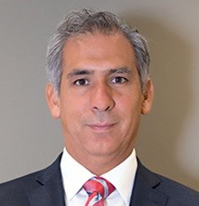
Antonio Macias Valdes is acknowledged as a leading authority on transfer pricing in Latin America. Antonio has assisted multinational companies in expanding or restructuring their business footprint in Latin America by coordinating their supply chain analysis. He also has extensive experience advising U.S. companies on managing and implementing their various transfer pricing needs, including: (i) structuring and pricing intercompany transactions; (ii) establishing internal processes and teams to effectively implement transfer pricing policies; and (iii) interacting with global tax authorities in order to assist clients with resolving transfer pricing audits.

Jeffrey L. Rubinger practices in the area of domestic and international taxation. He has been involved in tax planning for cross border mergers and acquisitions, international restructurings and joint ventures, and in the use of financial products in cross-border settings. In addition, Jeff has experience in a broad range of transactions involving U.S. taxpayers doing business overseas, foreign taxpayers conducting business in the United States, as well as federal, state and local tax issues involving corporate reorganizations, partnerships, and subchapter S corporations. Jeff lectures and has published several articles on domestic and international tax topics, including the taxation of financial products, the Foreign Investment in Real Property Tax Act, international tax consequences of cancellation of indebtedness income, the taxation of qualified subchapter S subsidiaries, Check-the-Box tax planning, subpart F income minimization, foreign tax credit planning, and tax planning with foreign holding companies.

Dr. Jens Schönfeld is a partner with Flick Gocke Schaumburg since 2005. Flick Gocke Schaumburg is a unique German law firm focusing on taxes. The firm has more than 100 partners and 350 associates, and is ranked as Germany‘s leading tax law firm. Prior to joining Flick Gocke Schaumburg, he was a member of the management of a medium-sized business group. He is a certified tax lawyer and a graduate in law and in business administration. His doctoral thesis focused on “CFC rules and European Union law.” Schönfeld has been designated an honorary professor at the University of Osnabrueck as well as a regular lecturer on international tax law at Bucerius Law School in Hamburg. He is a member of the Board and the Scientific Advisory Board of the German Tax Law Society, Editor of a German scientific journal on international taxation (“Internationales Steuerrecht – IStR”) and publisher of well-known books on international tax law and regular speaker on tax issues.

Dr. Jan H. Sedemund, LL.M. in taxation (USA). Dr. Sedemund is the Executive Vice President/Global Head of Tax, DPDL Group. He is an attorney/specialist lawyer for tax law, and has written several publications in the area of tax and company law.

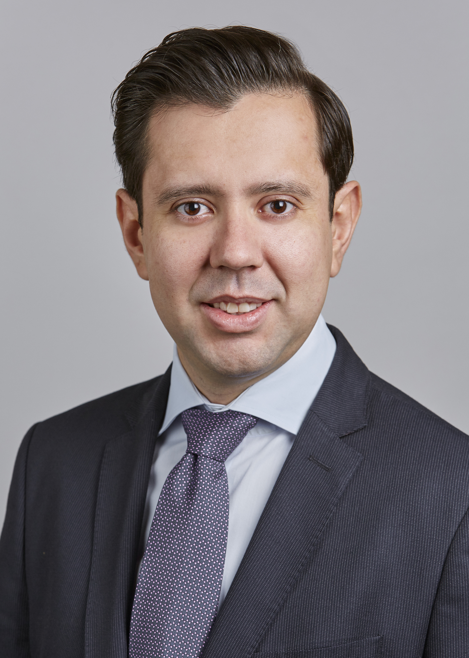
Carlos Vaca Valverde is a Director in PwC’s National Office in Washington DC, where his practice focuses on U.S. International Taxation. Carlos has ample experience advising clients on cross-border inbound and outbound transactions and the restructuring of global and regional operations. Prior to joining PwC’s National Office, he was part of PWC’s New York International Tax Services practice. Carlos received his LLM in International Taxation from The University of Florida, Levin College of Law.

Tifphani White-King is the International Tax Services Leader for Mazars USA. She has nearly 20 years of tax experience, providing operational, strategic, and marketplace direction for emerging, mid-market, and large multinational companies. Her expertise includes international tax structuring, transaction planning, mergers and acquisitions, tax provision, compliance reporting, and other related services. Tifphani leads global tax teams that provide expert services to a multitude of sectors including, inter alia, financial services, real estate, information technology, healthcare, and consumer discretionary products; and industries such as advertising, insurance, media, manufacturing, and logistics. Prior to joining Mazars USA, Tifphani was a Tax Principal at Deloitte, where she handled a broad range of inbound and outbound tax issues, including initial overseas investment, financing international operations, cross-border business structuring, tax provision, and compliance reporting. She also served as one of two International Tax Subject Matter Experts for the firm’s National Private Equity Steering Committee and was the National International Tax Services Leader for Insurance.

