University of Florida
Levin College of Law

Electronic Discovery
Law 6825 Class Number 24195
3-credits

Course Syllabus
Spring 2023

The exabytes of digital information streaming about us today are rich rivers of evidence that will help us find the truth and move us to do justice more swiftly, more economically and more honorably than ever before. It will require every litigator to master new skills and tools and alter the approaches and attitudes we bring to the adversarial process. We must reinvent ourselves to master modern evidence or be content with a justice system that best serves the well-heeled and the corrupt. The path to justice is paved with competent evidence and trod by counsel competent in its use.

-Craig Ball, www.craigball.com

Course Name: Electronic Discovery
Spring Semester 2023

Class times: Monday, Tuesday, Wed. 4:00 – 4:55 PM, Holland 285C

Office Hours and How Can You Contact Me:

I want to hear from you. Send me an email, call, or text.

Email | Telephone | Text | Office
hamiltonw@law.ufl.edu | 480.993.8777 | 480.993.8777 | Holland 376

Please let me know If you have something to share with me – an inspiration, a new thought, a frustration, or concern.

Zoom is one of my favorite video conferencing tools. We can have a face-to-face video conference any time (even on tablets and smartphones). I will also hold drop-in office hours from 2:00 - 3:00 PM Monday and Tuesday in my office, Holland 376.

Zoom | SKYPE
https://ufl.zoom.us/j/4591597877 | william.hamilton.1120

Why You Should Take This Course:

Electronic discovery is a critical litigation skill. Digital information is a principal form of evidence and often determines case outcomes.

Course Description:

This course will introduce you to the basic processes and technology of electronic discovery and offer a foundation in the federal and Florida civil procedure rules and federal case law governing the various phases of electronic discovery.

Learning Outcomes:

After successfully completing this course you will have obtained:

1. A working knowledge of the principal e-discovery issues encountered in litigation
2. A working knowledge of the legal framework required to analyze and resolve the multitude of e-discovery issues.
3. A working knowledge of a variety of industry-standard electronic discovery tools.
4. A working knowledge of all phases of the Electronic Discovery Reference Model. www.edrm.net.
5. A working knowledge of the best methods for the utilization of electronically stored information for motions, hearings, and trials.

I’m not a Computer Geek. Is This Course Over My Head?

This course does not require any advanced or specialized computer knowledge. The course will cover some very basic computer and computer network operations. As with any course, there will be some new vocabulary. If it is any comfort, I hold BA and MA degrees in philosophy

Will I Need to Become an Expert in Technology?

The short answer is “No.” However, you will need to commit to learning a modest new “technical vocabulary” and understanding some basic technology concepts and computer operations so you can knowledgeably “walk the walk” while “talking the talk.” This will not be difficult, and this course will provide all you will need. The course assumes no prior technical or computer knowledge. I think you will find it fun to understand the basics computer operations that few people really know. Every Wednesday we’ll have a “Tech Wednesday” event about neat things.

Will I Need to Master Complicated E-Discovery Software?

Becoming familiar with the e-discovery tools that we will use in this course will help you understand the challenges of electronic discovery and how the law has evolved. Basic familiarity with e-discovery software will give you a practice jump start when you leave law school.

Who Is Your Professor?

I joined the UF Law faculty after 30 years practicing complex civil litigation with Holland & Knight in Miami (1983 – 2000) and Tampa (2000 – 2010) and with Quarles & Brady in Tampa (2010 – 2016). Electronic discovery changed my career when I realized it was a rich source of evidence that would win cases for my clients. Before leaving the practice of law, I was a UF adjunct professor for 10 years and established the UF E-Discovery Project and the UF Law E-Discovery Conference.

I am from Philadelphia. I hold a BA in philosophy from Lehigh University in Bethlehem, Pennsylvania, and an MA in philosophy from Washington University in St. Louis, Mo. I graduated from UF Law in 1983.

Here are a few links where you can learn more about me.

https://www.law.ufl.edu/faculty/william-hamilton
https://www.law.ufl.edu/areas-of-study/institutes/icair
https://www.linkedin.com/in/williamfhamilton/

I am married to Cynthia Tejcek. Cindy graduated from Loyola University in Chicago with a BS in mathematics. She also holds an MBA from Kellogg School of Management at Northwestern University. We meet when she was the chief information officer of the American Bar Association.

We have a son who is an Army Captain having graduated from the University of West Florida with a degree in mathematics.

We have another son who is a trauma RN and supervisor at Lakeland Memorial Hospital’s Emergency Department.

Our daughter is a UF graduate in criminology and communications. She is a sergeant with the Florida Department of Corrections.

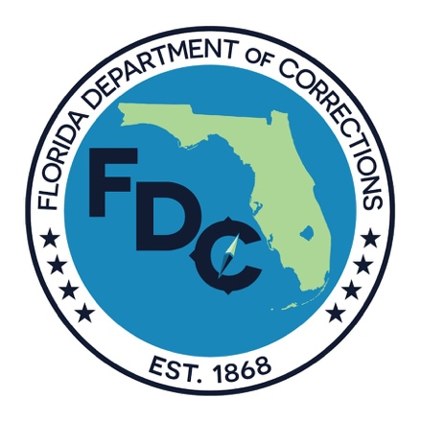

Teaching Philosophy and Instructional Methods:

This course has a practical orientation. You will learn the Federal and Florida Rules of Civil procedure governing electronic discovery and read cases. The emphasis of the course is on solving the practical electronic discovery problems. You will learn to act like an e-discovery lawyer in this class.

My teaching philosophy is in large part captured in Make It Stick: The Science of Successful Learning by Peter C. Brown.

This course is designed to introduce you to a variety of career paths involving e-discovery skills. I recommend the book
“Designing Your Life: How to Build a Well-Lived Joyful Life,” by Burnett and Evans, Alfred A. Knopf (2016), for helpful strategies to find career directions that will work for you.

Attendance:

You are expected to attend all class sessions. Each week you will be asked to read certain basic cases, statutes and text. At approximately every four weeks there will be a 20-minute low stakes quiz to give you some feedback on how we are doing. You will take the Quiz at home. If you cannot attend a class, you must email me in advance and I will provide you with attendance points for that class. An excuse is not required. Do not lose attendance points.

Is this Course Graded on a Curve?

This course is graded on a curve. I am provided a curved grade range by the Registrar and my class grade average must be within that range. In past semesters my curved average has been in the range of 3.35.

Course points may be earned as follows:

1. Final examination: 700 points (approximately ½ the total class points)

There will be a 3-hour final examination. The final examination will require you to analyze factual scenarios, identify the appropriate legal rules, apply the rules, and reach a conclusion. The final examination may include a multiple-choice section.

Essay questions of the final examination will be graded on the following rubric:

- Identification of e-discovery issues presented by the scenario,
- Analysis of the e-discovery issues presented by the scenario,
- Application of case law and civil procedure rules to the issues presented by the scenario,
- Resolution of the issues presented by the scenario,
- Felicity, conciseness, and richness of the written expression.

The examination will be administered by the Registrar’s office. The examination will include materials and topics discussed in class in addition to the readings.

2. Class Attendance and Participation: 200 points (5 points per class).

Class attendance and participation are expected. Each class is worth 2 points.

Class participation requires:

- Asking and answering questions that illuminate the issues,
- Asking and answering questions that enrich the class dialogue and advance the classes understanding of the issues,
- Participating in the class dialogue and discussions,
- Participation team debates and mock exercises,
- Engaging in class activities, exercises and projects.
- Demonstrating class preparation.

I recognize that you may have legitimate and compelling personal and professional requirements that may cause a class absence. If you will not be attending a class for personal or professional reasons, please notify me in advance as a professional courtesy. I will provide attendance points for students who notify me in advance by email of an absence. If you have not provided me with advanced notice, attendance points will be provided for missed classes on a showing of circumstances excusing prior notification.

3. Low Stakes Check-Ups: 120 points.

There will be three 20-minute “check-up” quizzes that will consist of multiple-choice, true/false, and matching or short answer questions. Each of the checkups will be worth 40 points. The check-ups are designed to give you feedback and a reality check on how well you understand the course materials presented so far and to provide feedback to me on what course areas and topics may need additional attention. These will be take-home quizzes.

4. Weekly and Bi-Weekly Exercises and Assignments: 400 points.

We will have short exercise assignments on a regular basis designed to help familiarize you with electronic discovery software and processes. Most of these exercises are graded on a pass/fail basis and merely require the completion of the exercise.

Are Smartphones and Laptops Permitted in the Classroom?

You may use digital devices in class only to take notes. I will turn my phone off when I come to class. Please do the same. Please restrict the use of your laptop to taking notes. During class do not visit social media websites, do not text, and do not email. Keep your web browser closed to avoid temptation. Do not abuse this privilege. I expect your attention in class. Nothing life-changing will happen while you are offline in class.

What Notes Should I Take in Class?

I recommended that you do not take word-for-word literal notes. This is not a court reporting class! Instead, think about what is happening in class and record the key ideas. Handwriting your notes is better for you than typing notes. Check out this article: Note-Taking: Writing vs. Typing Notes. Beyond that, it is a good legal skill. You will need to learn to take good witness interview notes, deposition notes, and trial notes. A computer will not always be available or good to use.

What Happens if I am Late Turning in an Assignment?

Every assignment is on Canvas. Canvas provides three dates for each assignment: a date when the assignment is open, a date when the assignment is due, and a date when the assignment is closed. Each assignment opens at 9:00 Tuesday of the week it is due. All assignments are due the following Friday at 5:00 PM. These assignments are typically easy points. Do not miss an assignment and lose the points.

Make-Up Examination, Quiz, and Assignment Policy:

The law school policy on delays and accommodations can be found here.

Assigned Text (specific assignment will be provided from each source);

LexisNexis Practice Guide Florida E-Discovery and Evidence, Artigliere and Hamilton(2020)
http://www.lexisnexis.com/store/catalog/booktemplate/productdetail.jsp?pageName=relatedProducts&prodId=prod14330392. (free online access for UF students).

Project Management in Electronic Discovery, M. Quartararo (2021) (modest $20.00 purchase).

eData Deskbook, Fourth Edition, Morgan, Lewis & Bockius LLP 2021(free download for UF Law Students).

EDiscovery for the Rest of Us, Tom O’Connor, 2021 (free download for UF Law Students).

Weekly Class Objectives, Schedule, and Assignments:

The specific weekly lesson, objectives, reading materials, assignments, and exercises are on the course Canvas page. The course Canvas website is the official class record and schedule. Please refer to it and not this syllabus for information regarding class lessons, objective, reading materials, assignments, and exercises. Each class we will read cases, study rules, read secondary sources and discuss practical e-discovery problems. The class reading assignments and exercises are posted on the course Canvas page.

Week 1:
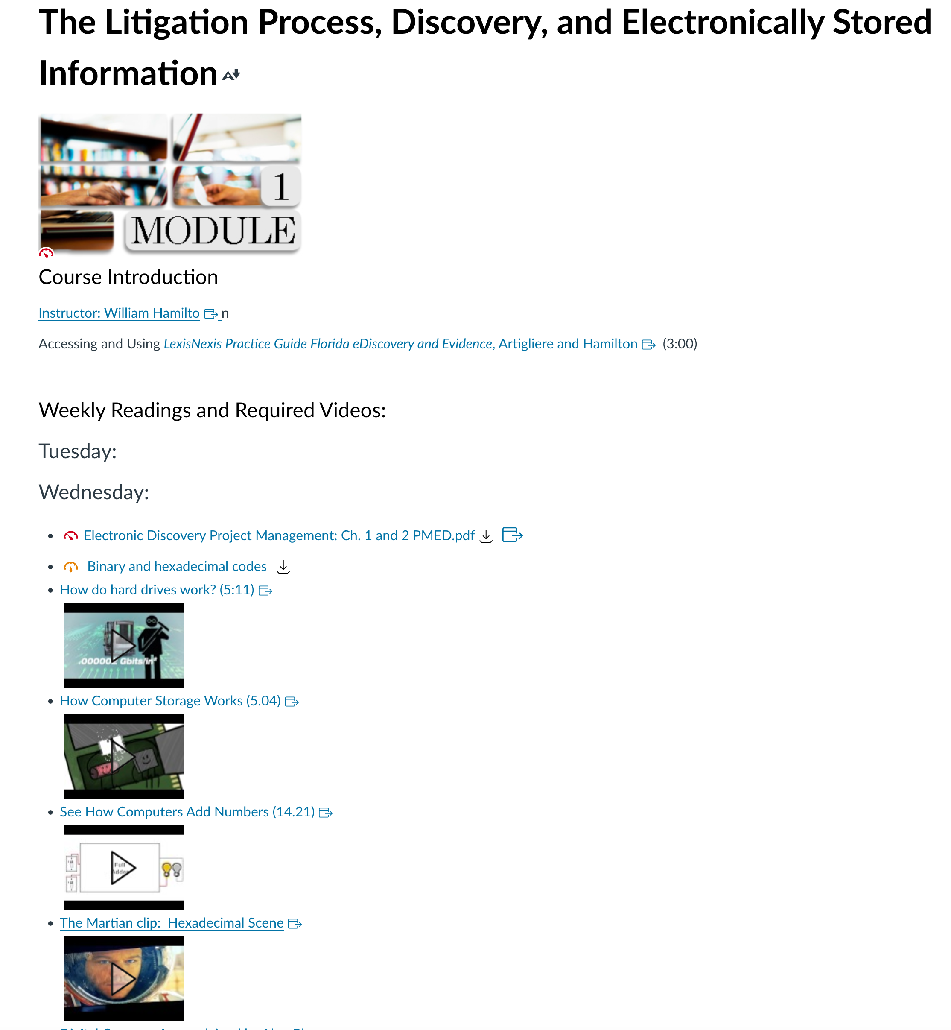

Week 2:
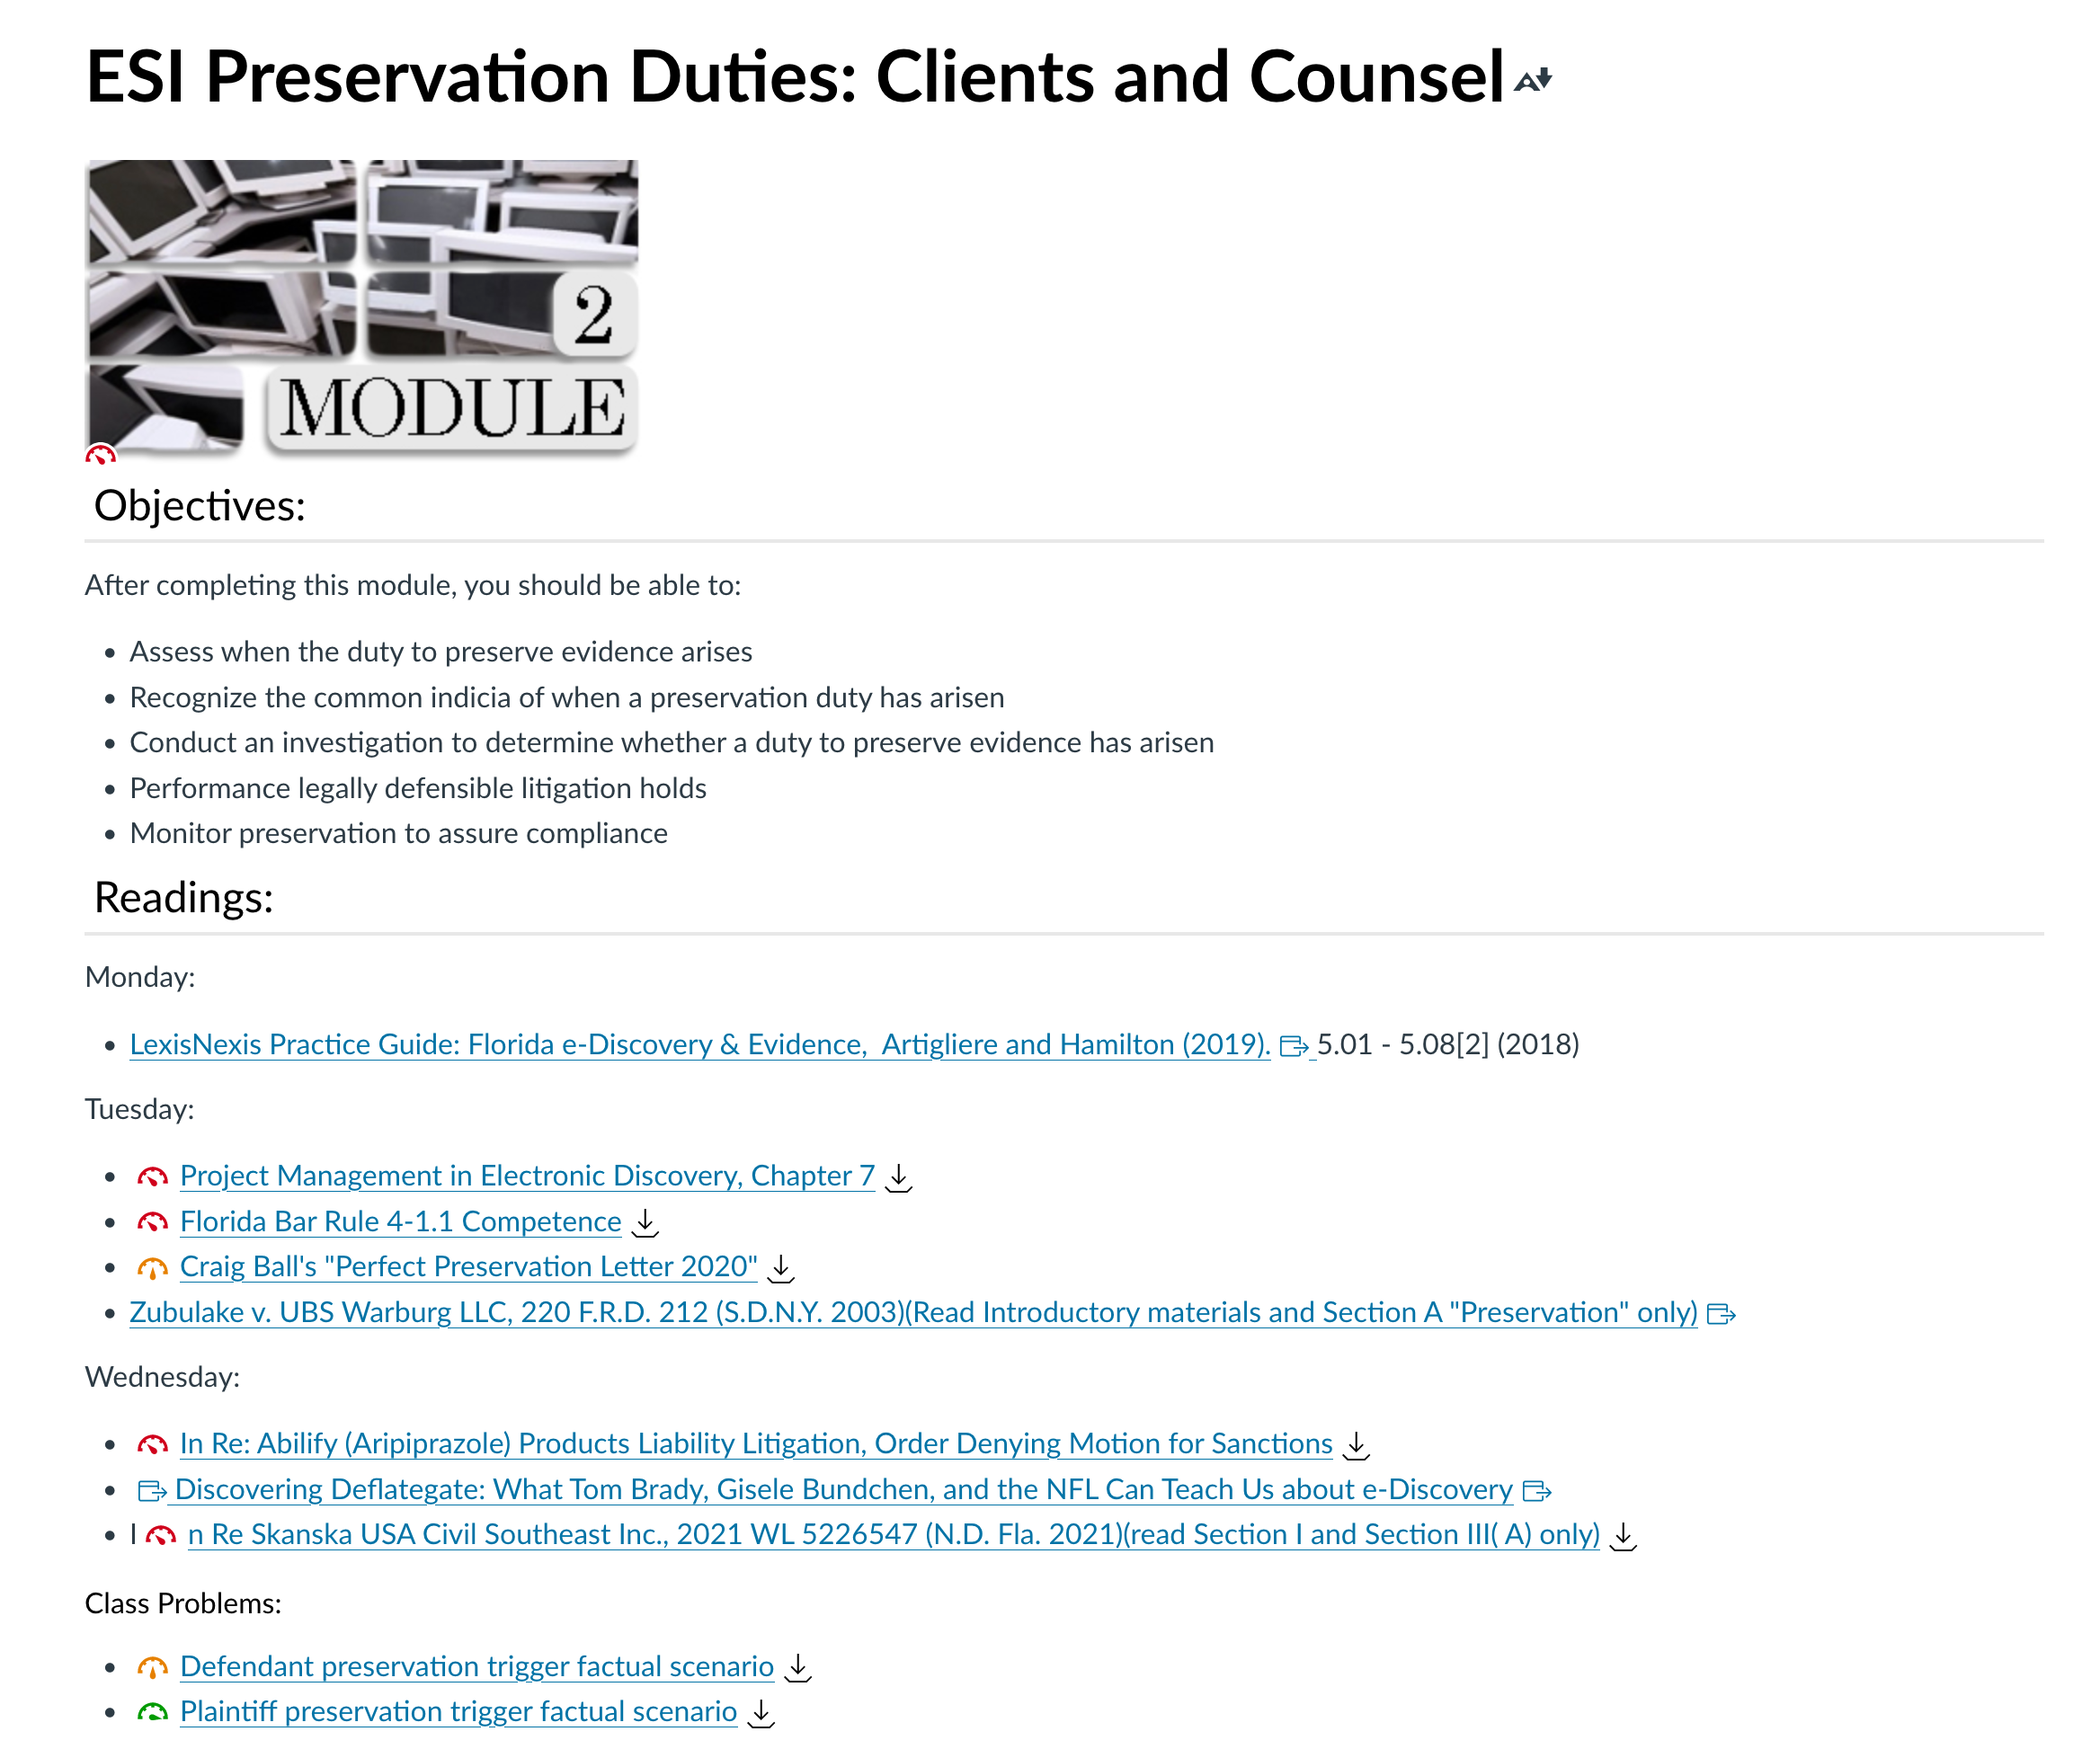

Week 3:
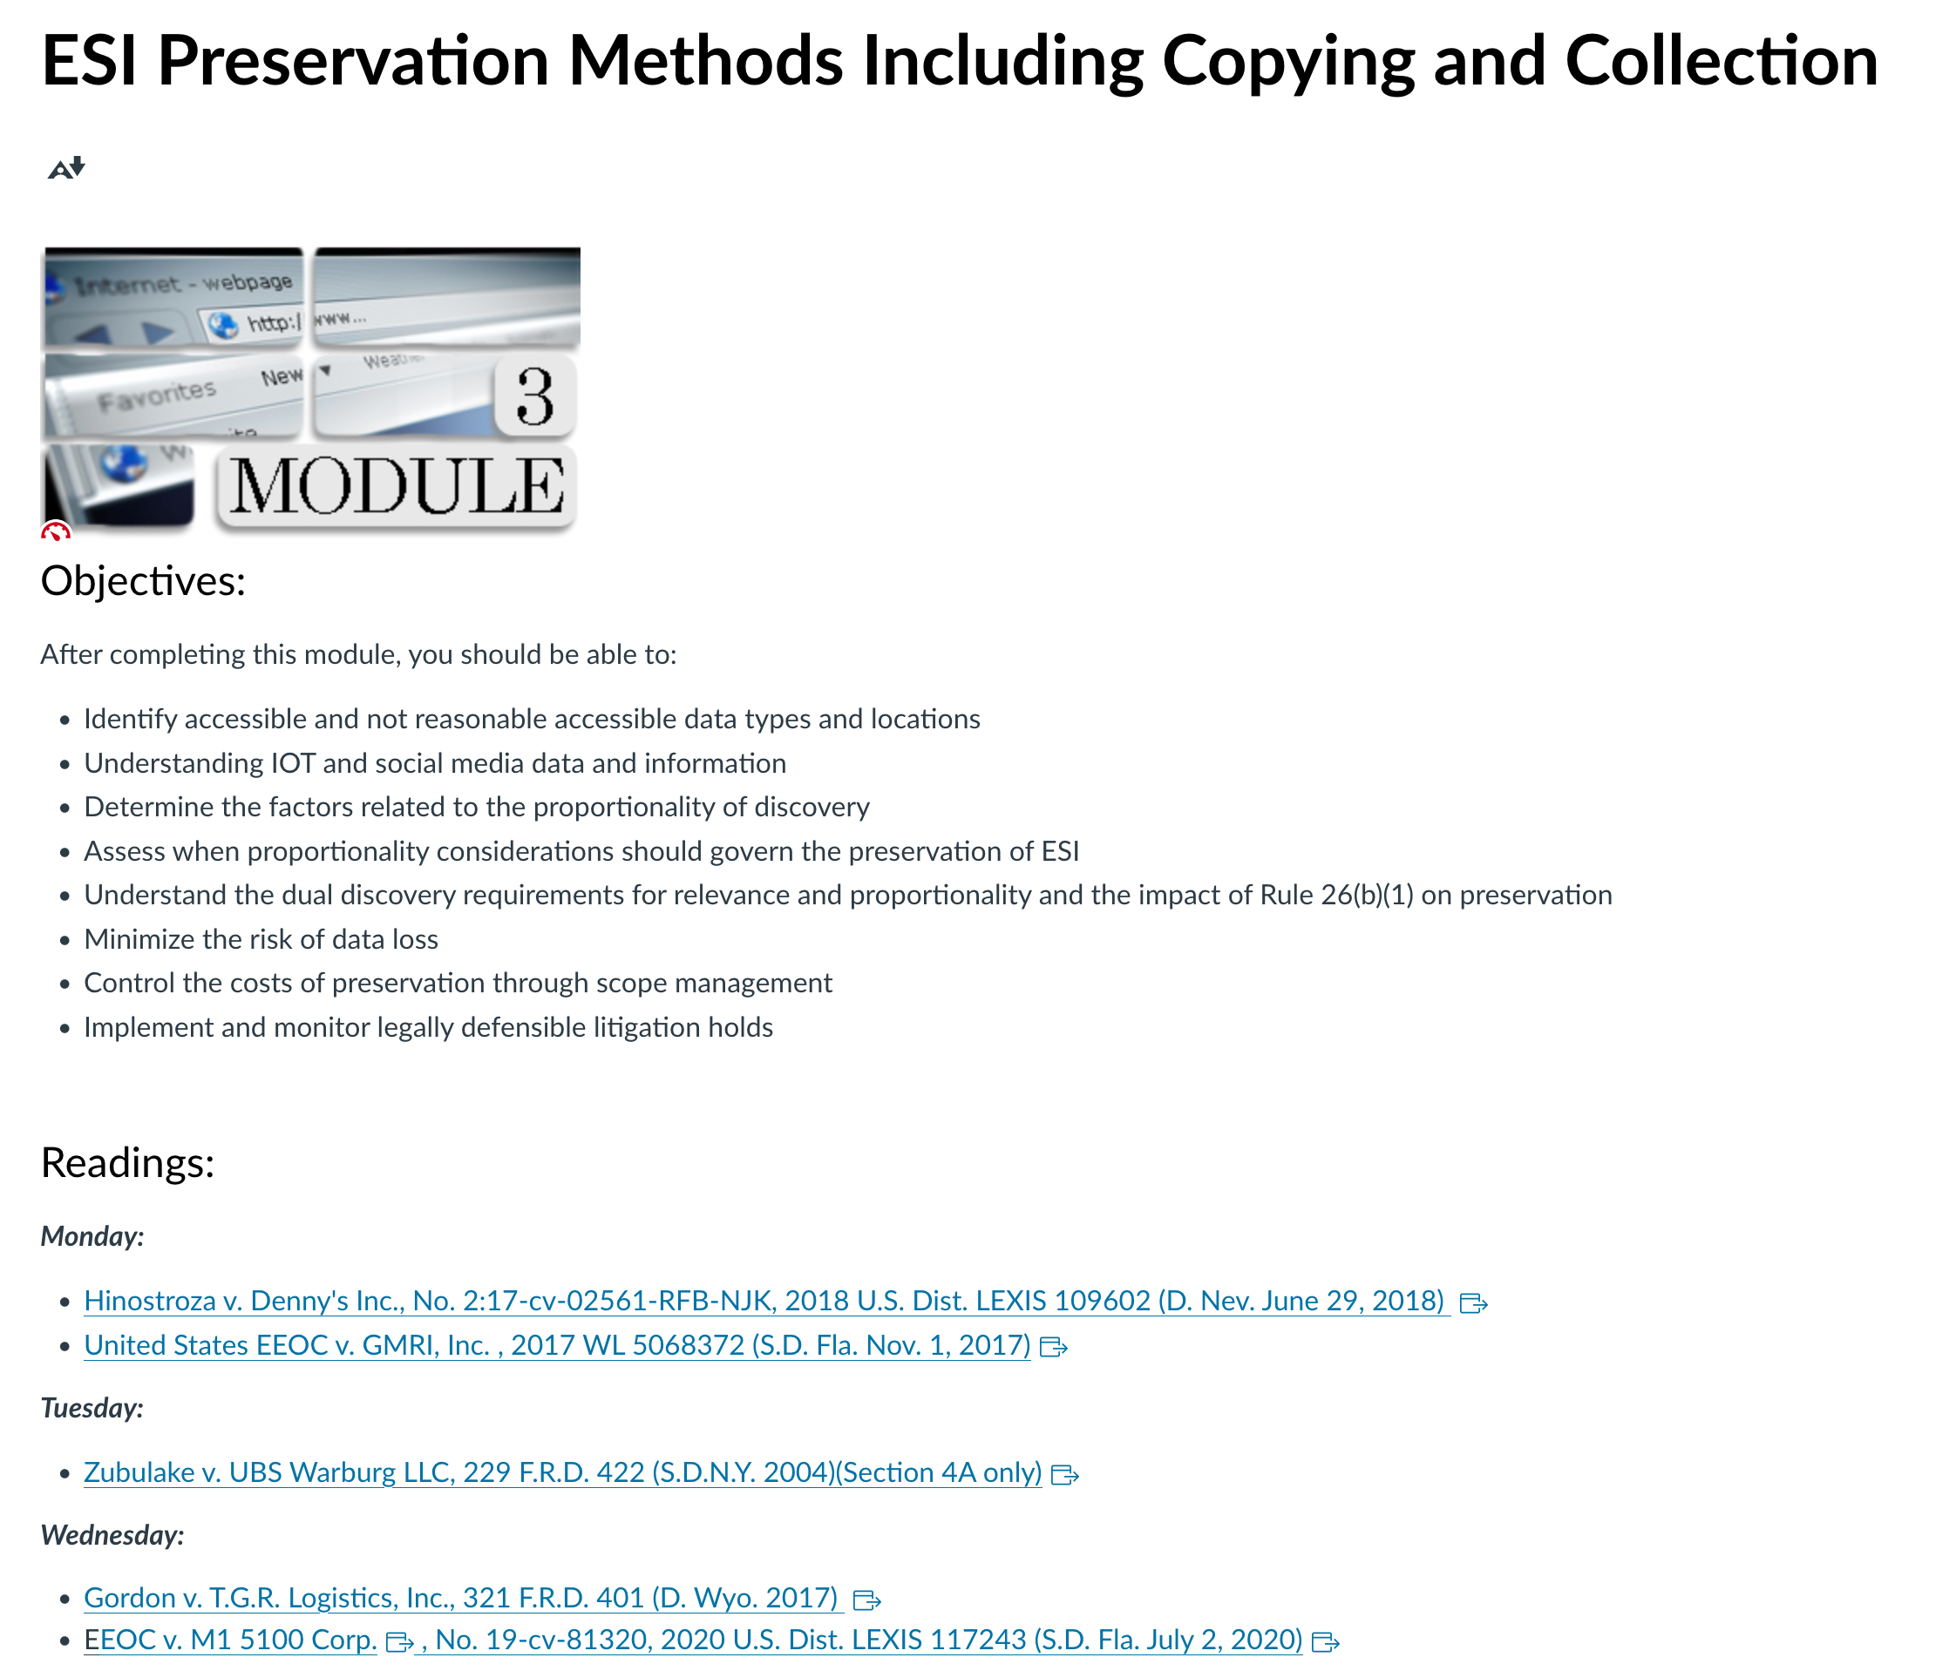

Week 4:
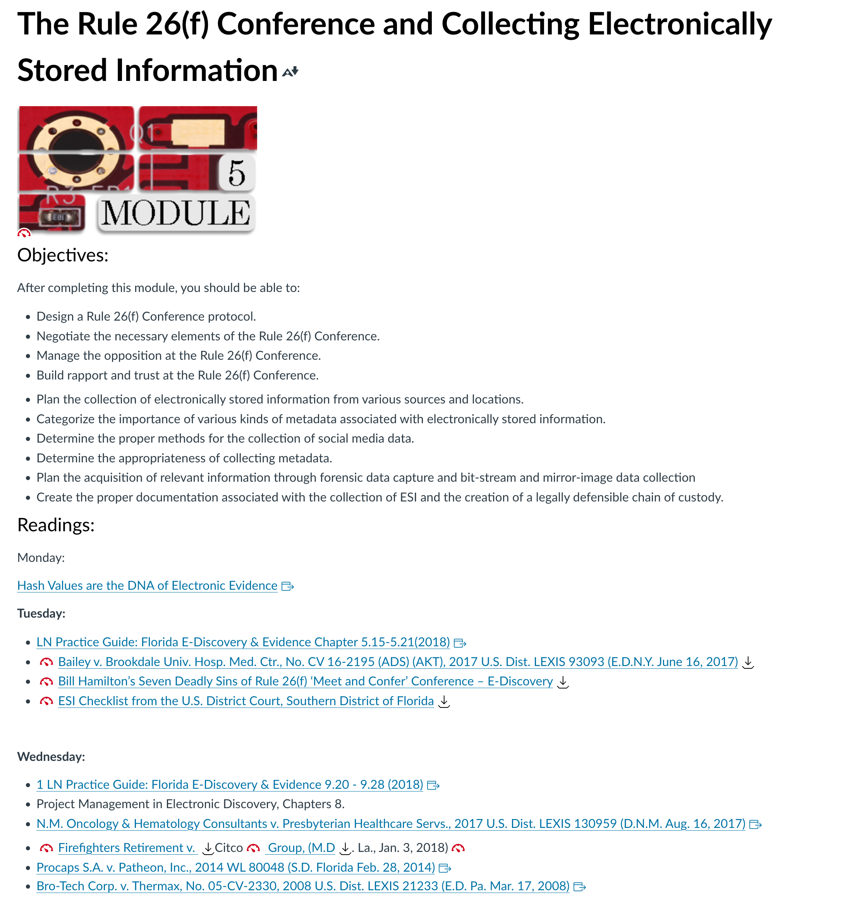
Week 5:
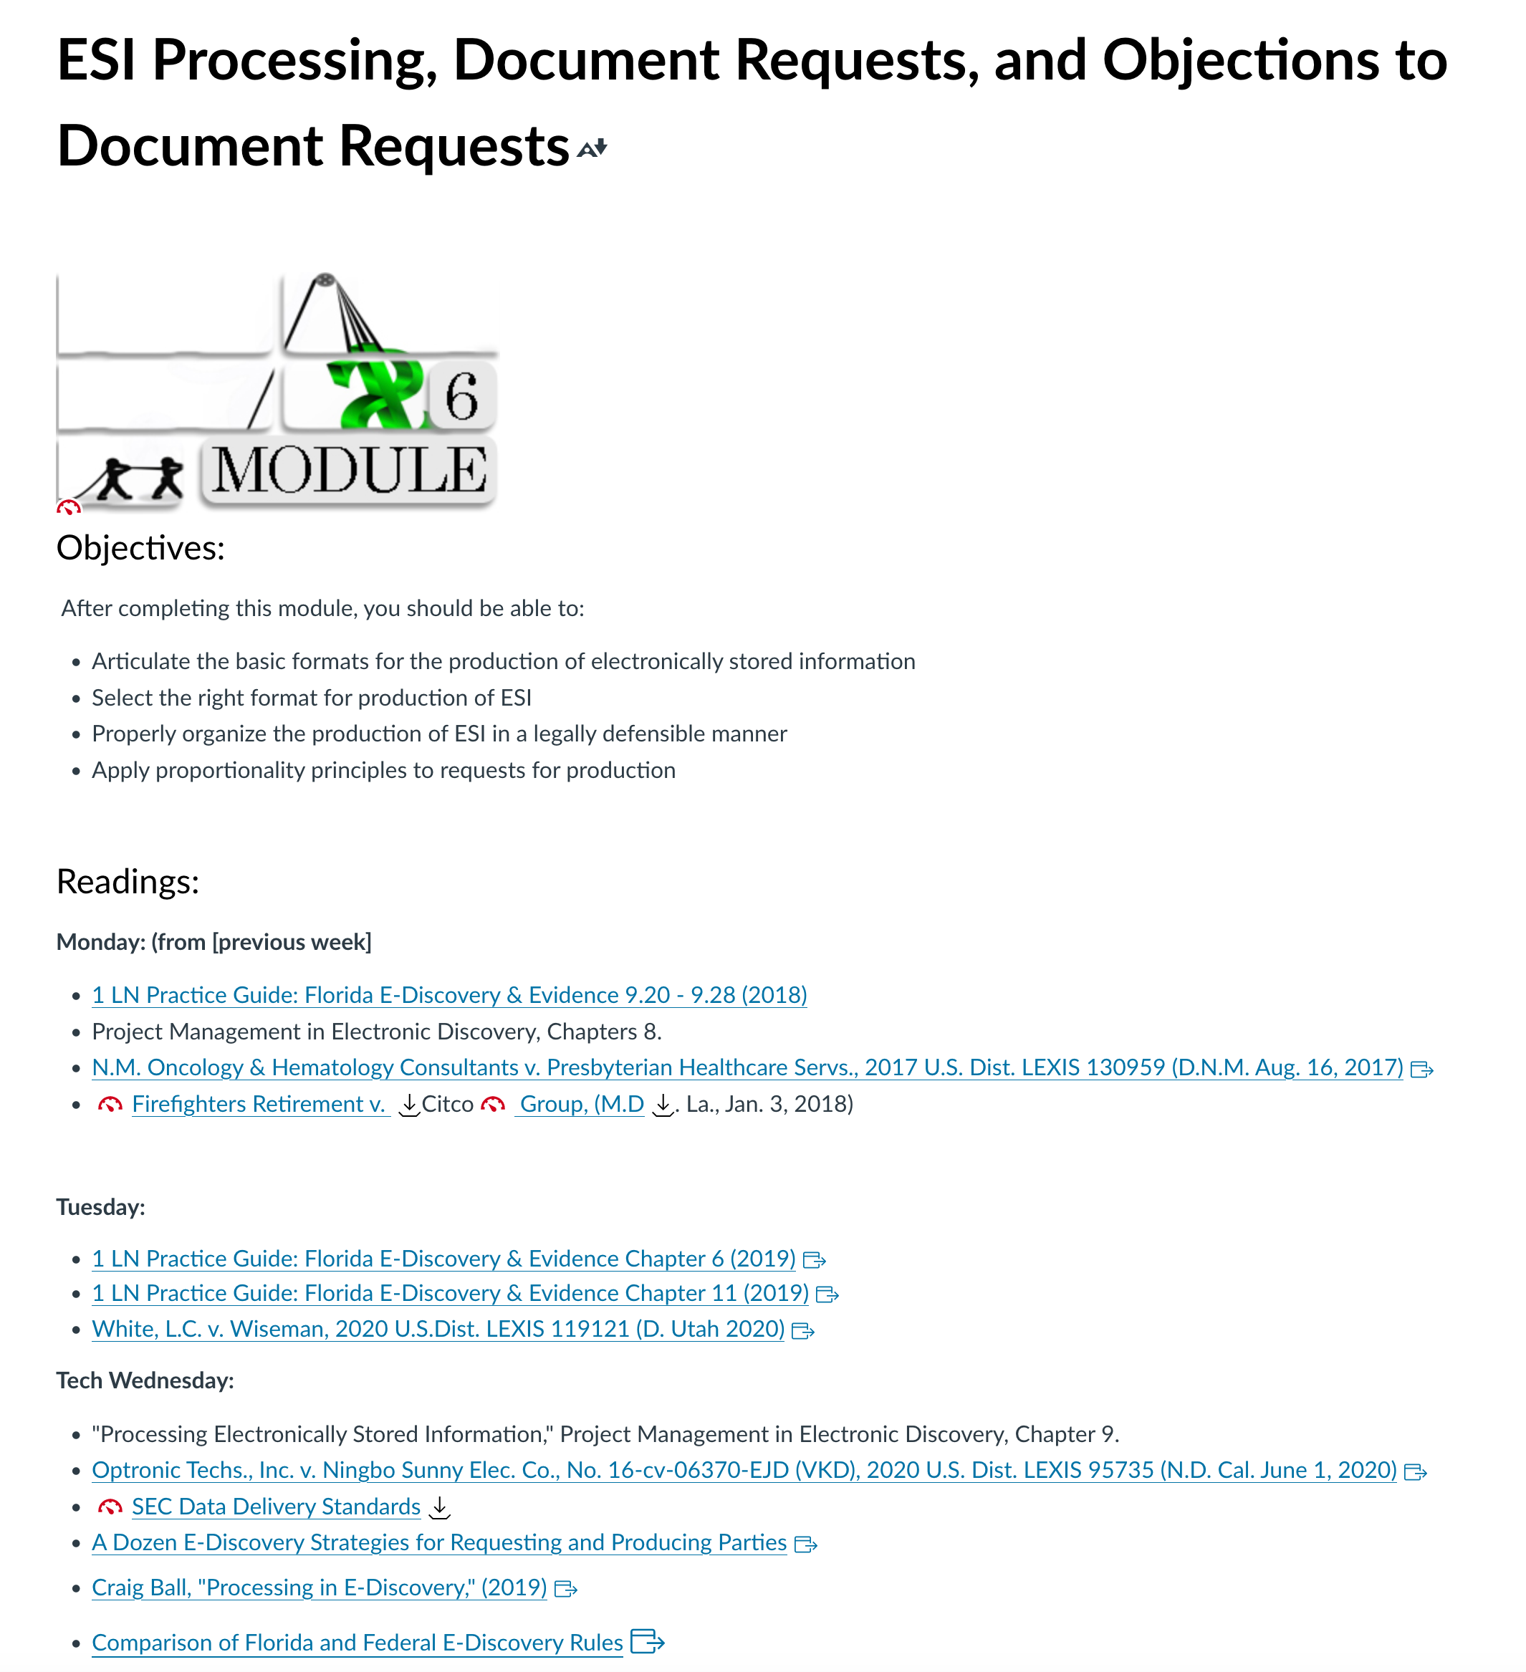

Week 6:
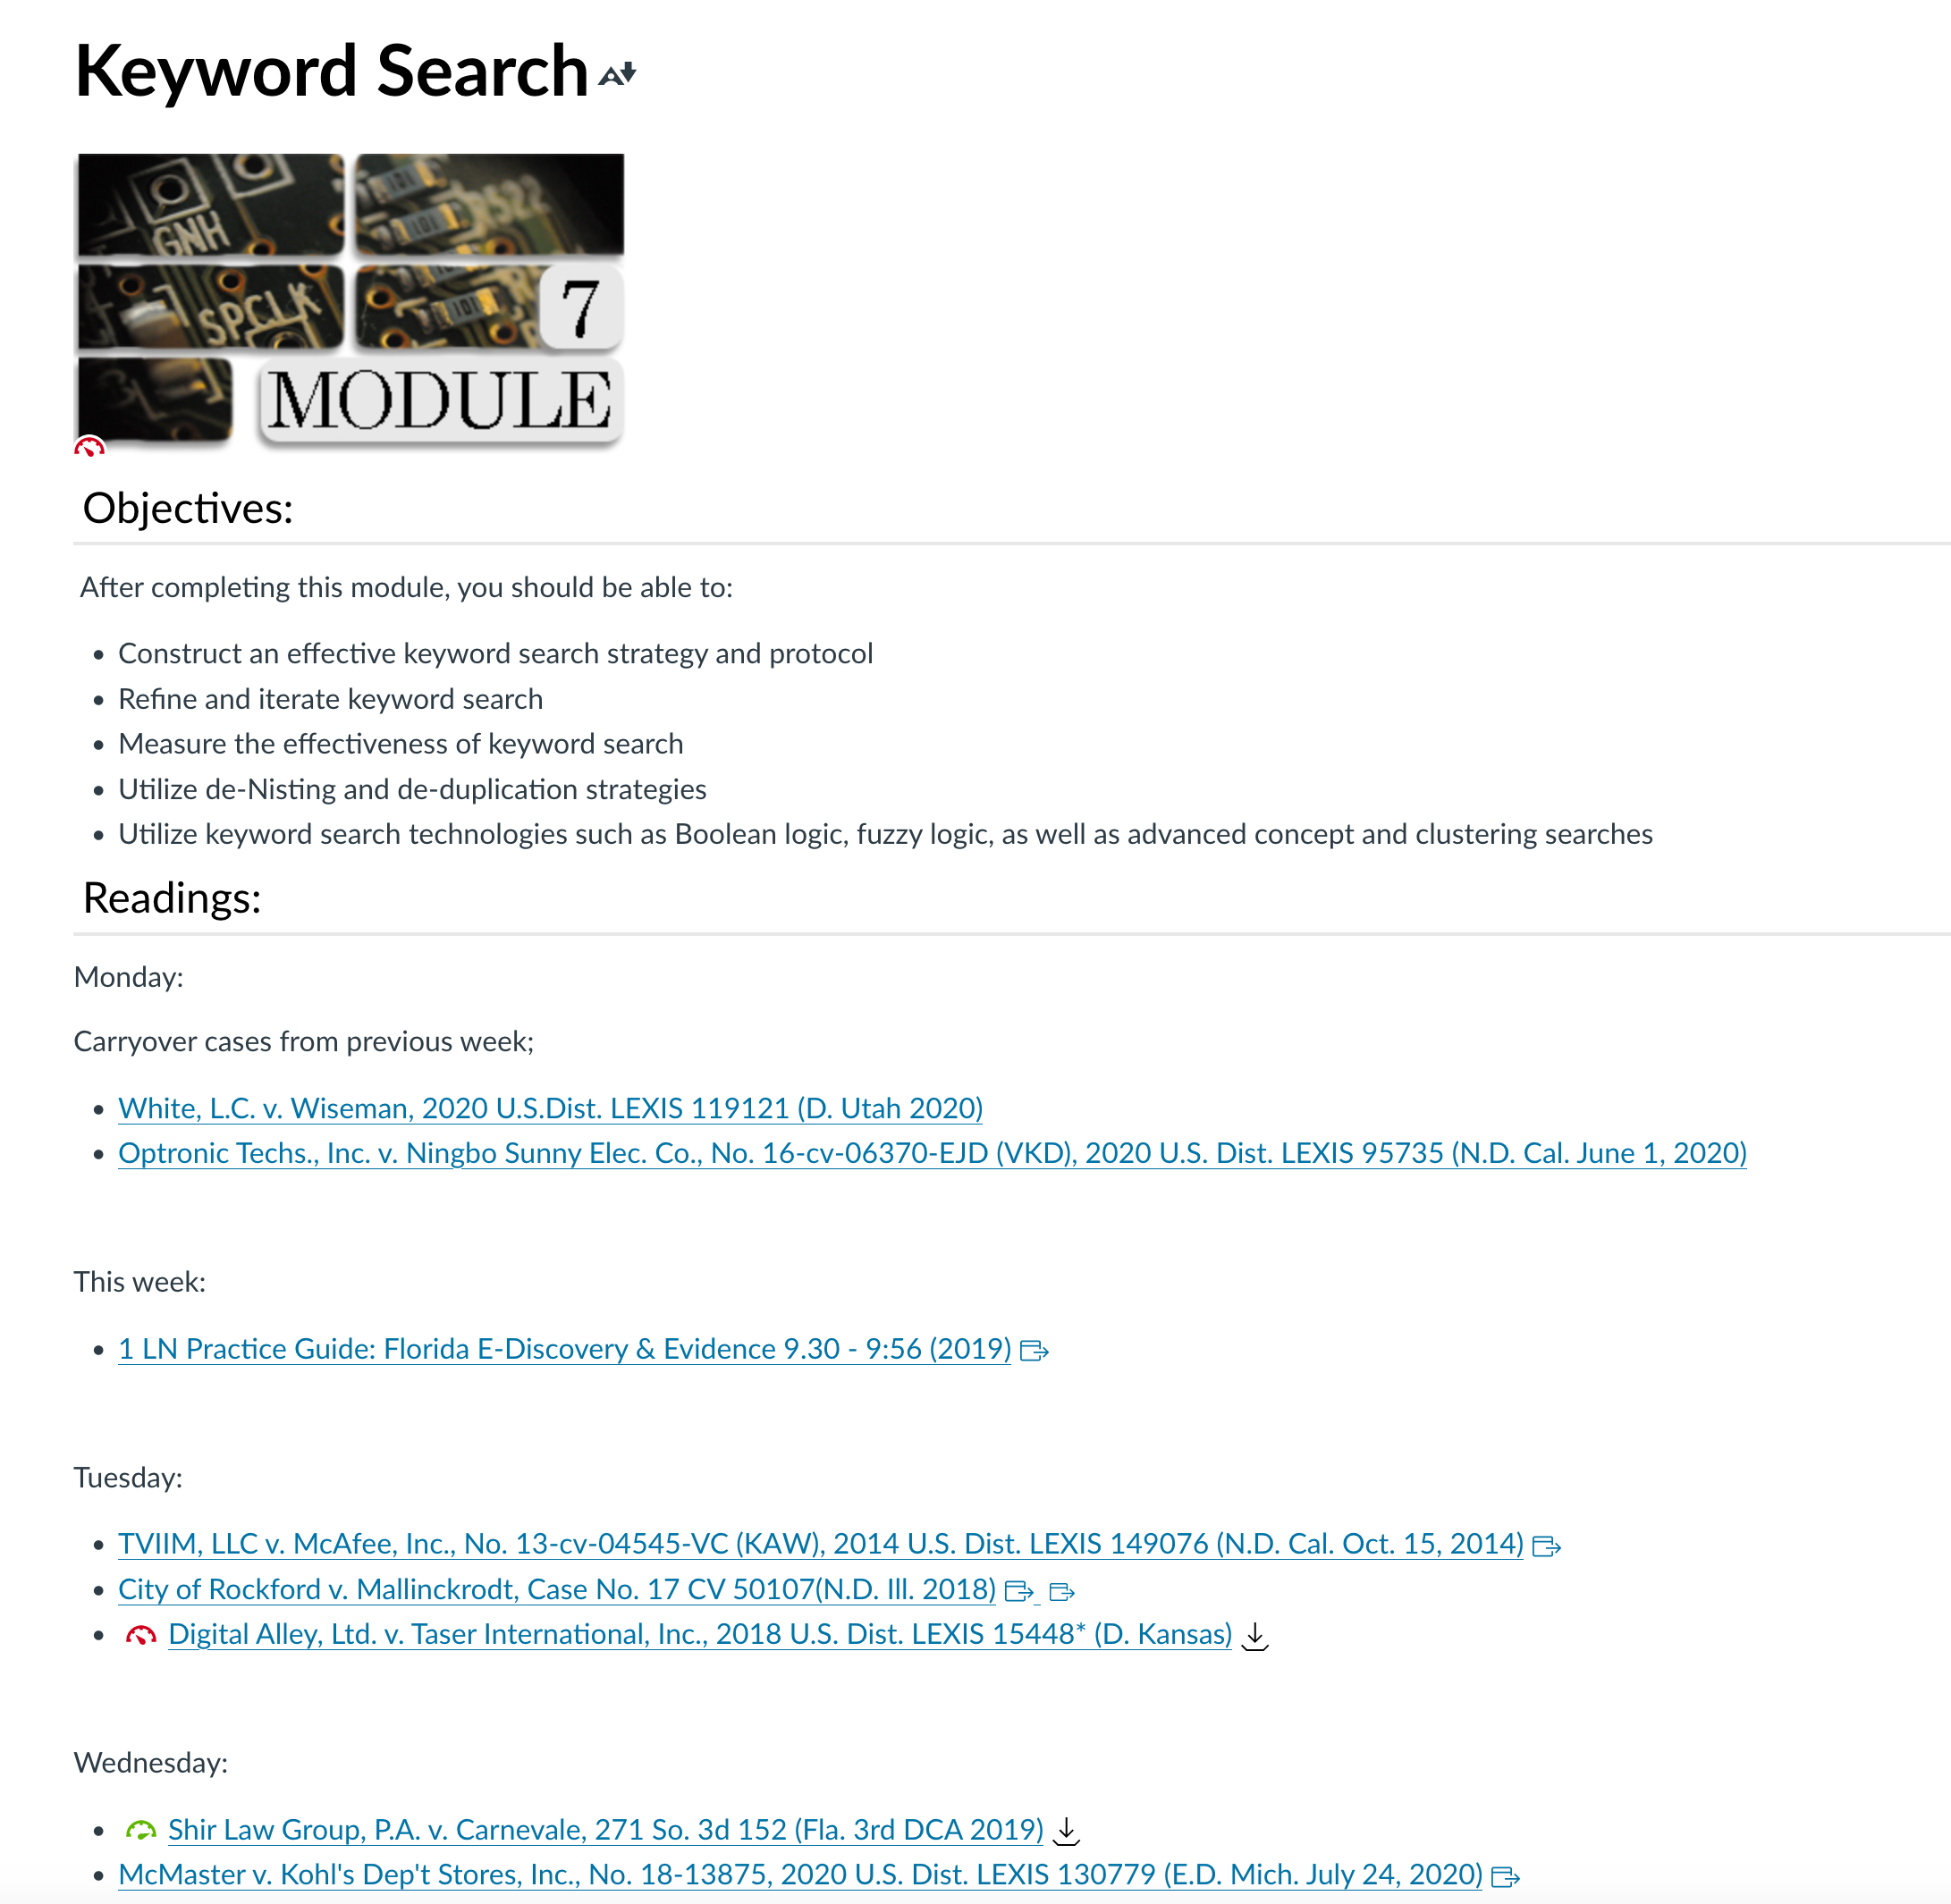

Week 7:
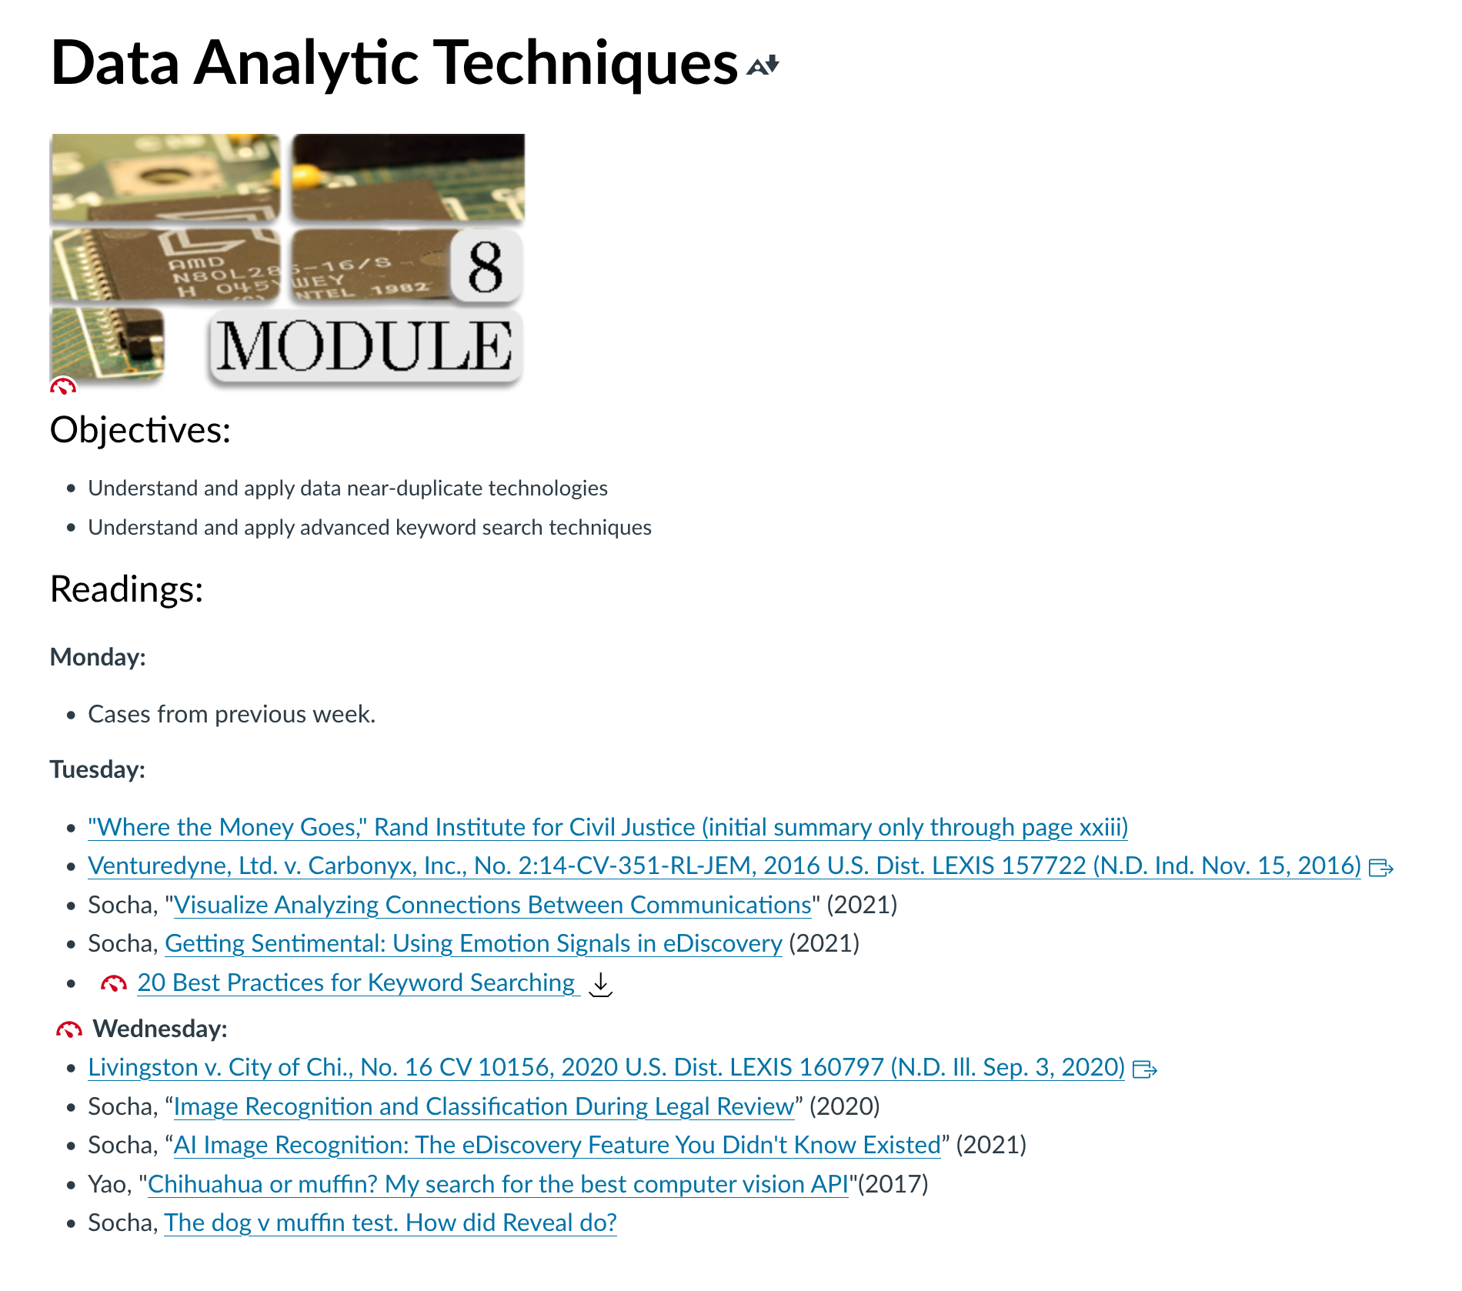

Week 8:

Week 9:
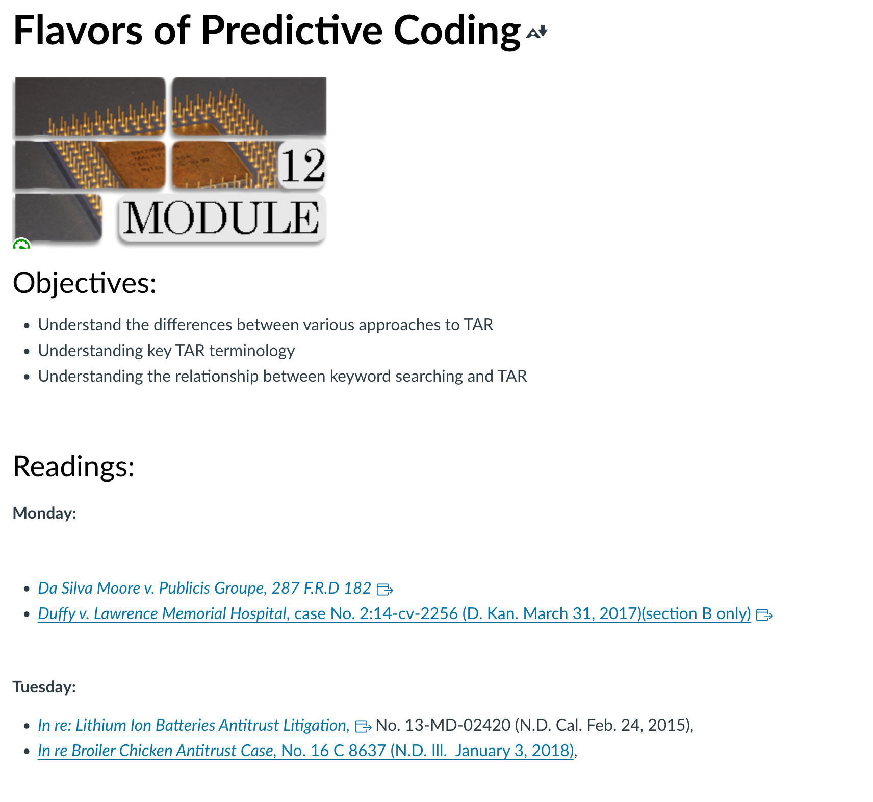

Week 10:
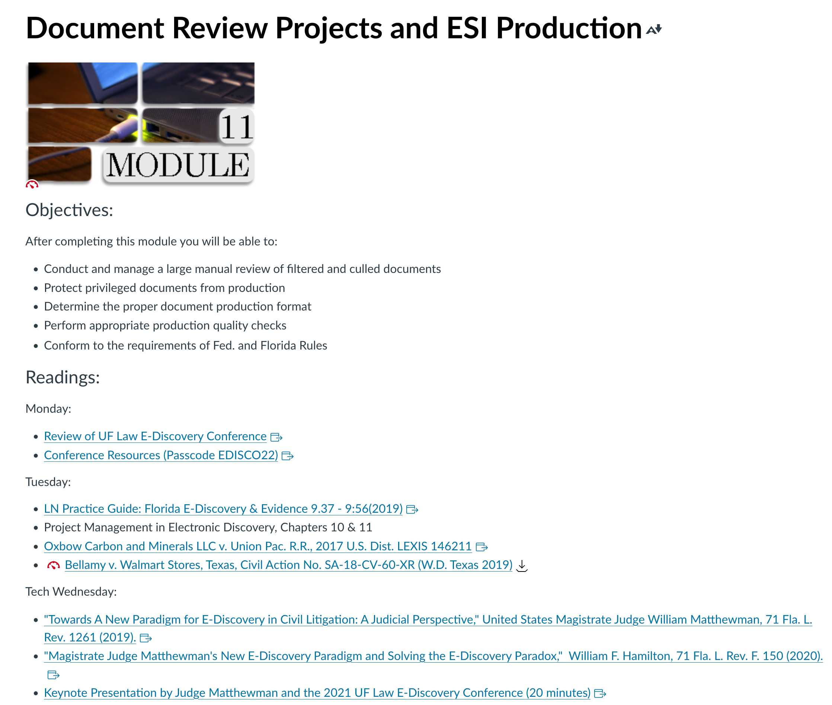

Week 11:
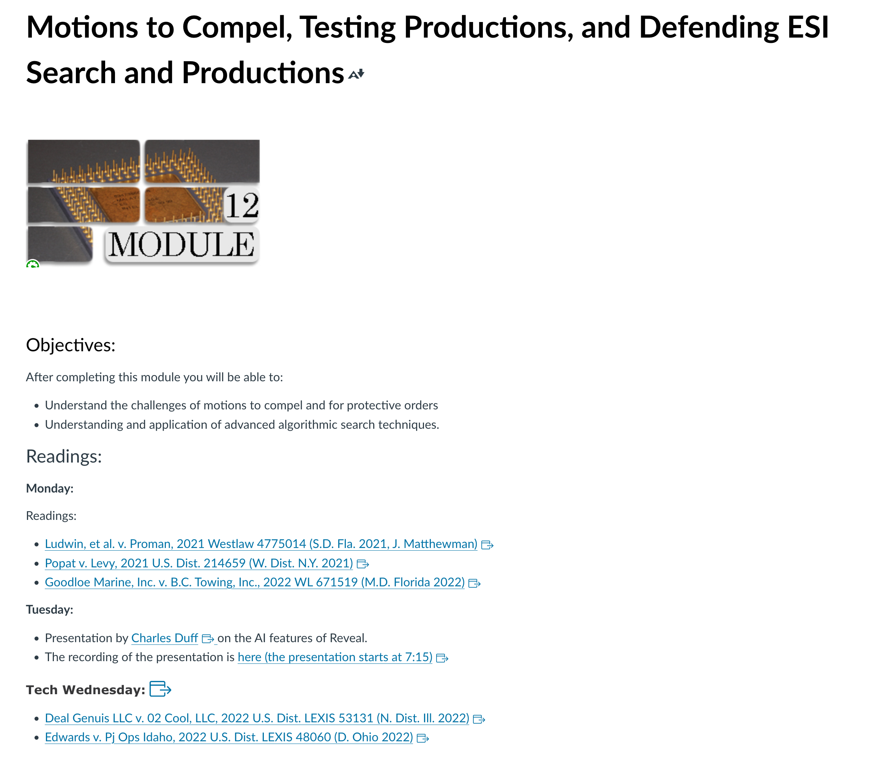

Week 12:
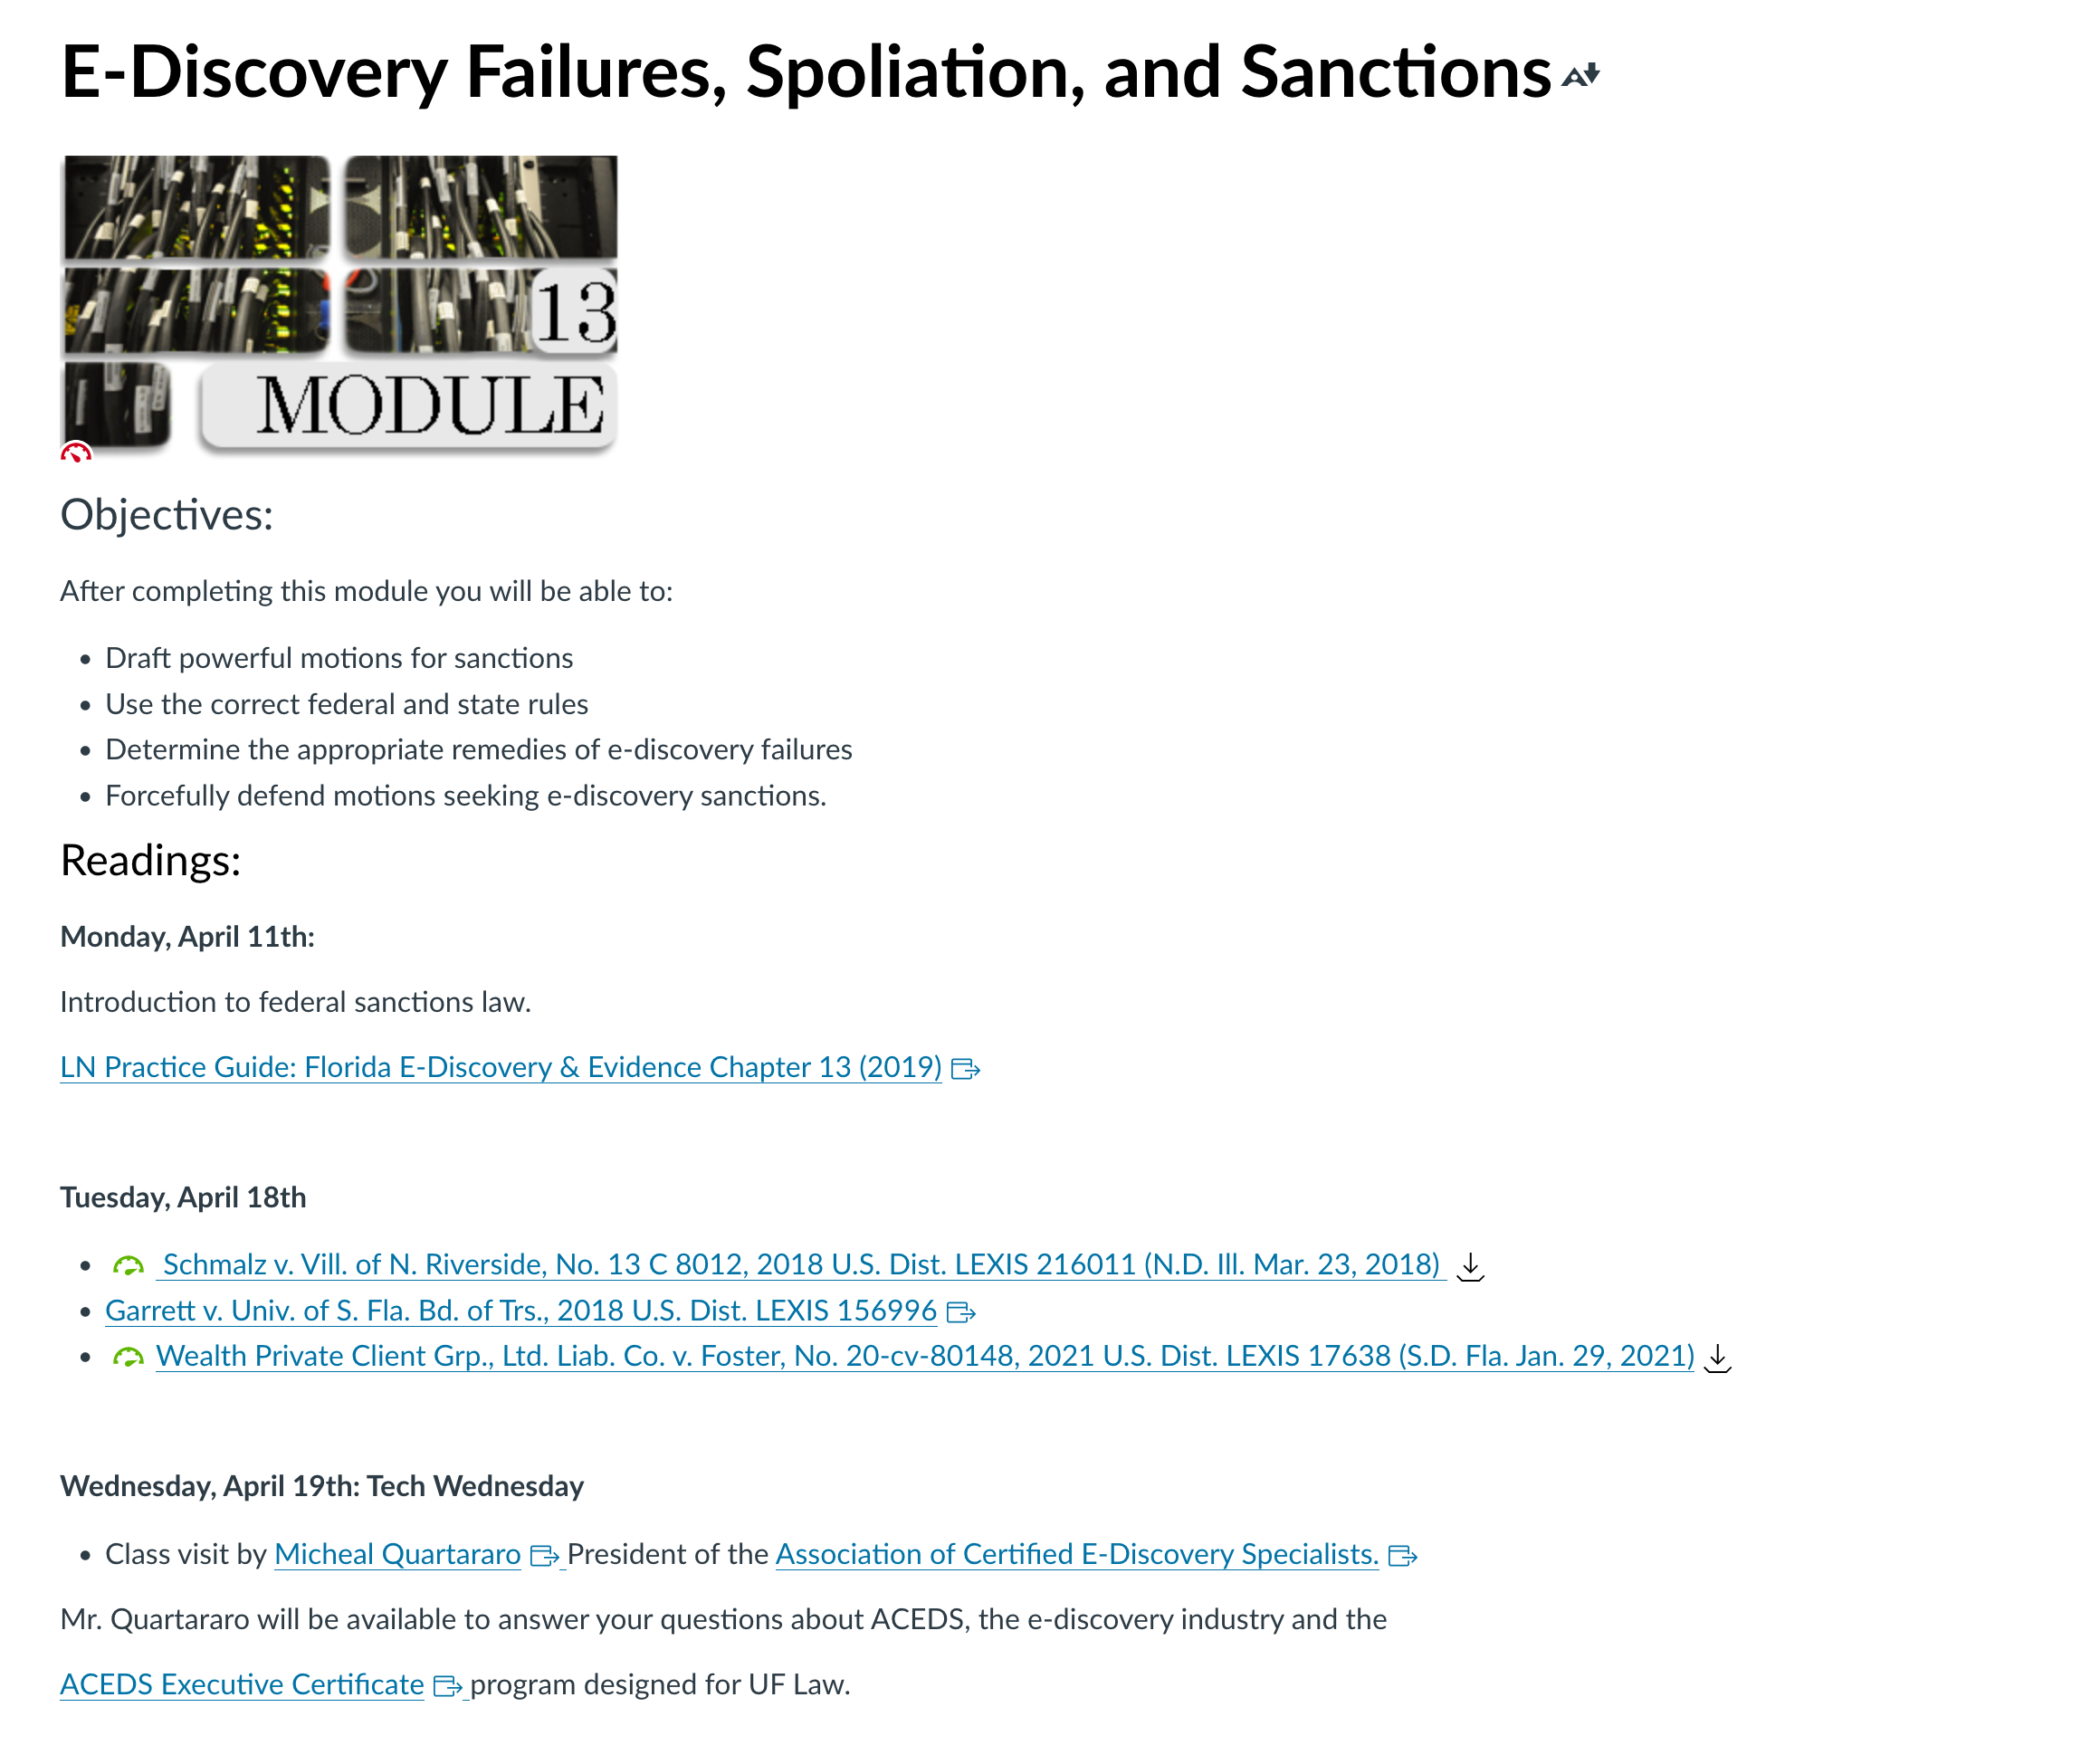

Week 13:

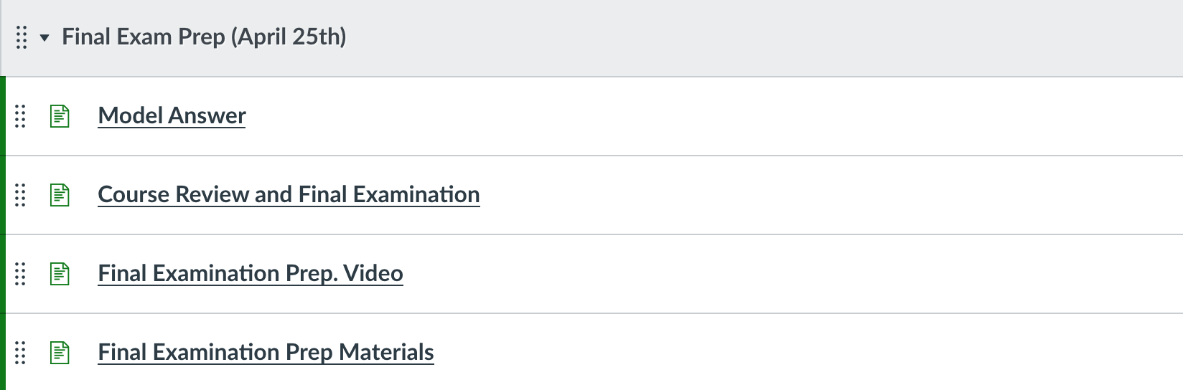

I reserve the right to make reasonable adjustments and modifications to the weekly schedule as required by the pace and progress of the class, including, but not limited to additional or reduced assignments, readings, and exercises.

Workload/class preparation and the 2:1 out of class/in class requirement (ABA Standard 310):

- You should expect to spend, on average, approximately two hours preparing for every hour of class. Reading assignments are posted on the “Modules” link on the Canvas site (located on the left side of the Canvas site).
- It is anticipated that you will spend approximately 2 hours out of class reading and/or preparing for in class assignments for every 1 hour in class.
- ABA Standard 310 requires that students devote 120 minutes to out-of-class preparation for every “classroom hour” of in-class instruction. (Course) has 3 “classroom hours” of in-class instruction each week, requiring at least 6 hours of preparation outside of class. Accordingly, you will have about 60 pages of reading each week. Because the course includes statutory and regulatory excerpts that require careful reading, as well as discussion problems that require thoughtful advance written preparation, you should spend at least one hour on every 10-15 pages of reading.

Statement related to accommodations for students with disabilities:

Students requesting an accommodation for disabilities must first register with the Disability Resource Center (http://www.dso.ufl.edu/drc/). Once registered, students will receive an accommodation letter which must be presented to the Assistant Dean for Student Affairs (Dean Mitchell). Students with disabilities should follow this procedure as early as possible in the semester.

Information on UF Law grading policies:

Grade Points Grade Point Grade Point
A (Excellent) 4.0 C+ 2.33 D- 0.67
A- 3.67 C (Satisfactory) 2.00 E (Failure) 0.0
B+ 3.33 C- 1.67
B (Good) 3.00 D+ 1.33
B- 2.67 D (Poor) 1.00

The law school grading policy is available at: https://www.law.ufl.edu/life-at-uf-law/office-of-student-affairs/current-students/uf-law-student-handbook-and-academic-policies .

University policy on academic misconduct:
Academic honesty and integrity are fundamental values of the University community. You should be sure that they understand the UF Student Honor Code at http://www.dso.ufl.edu/students.php.

Online Course Evaluation:

Students are expected to provide professional and respectful feedback on the quality of instruction in this course by completing course evaluations online via GatorEvals. Guidance on how to give feedback professionally and respectfully is available at https://gatorevals.aa.ufl.edu/students/. Students will be notified when the evaluation period opens and can complete evaluations through the email they receive from GatorEvals in their Canvas course menu under GatorEvals or via https://ufl.bluera.com/ufl/. Summaries of course evaluation results are available to students at https://gatorevals.aa.ufl.edu/public-results

Preferred Name and Pronouns:
It is important to the learning environment that you feel welcome and safe in this class; and that you are comfortable participating in class discussions and communicating with me on any issues related to the class. If your preferred name is not the name listed on the official UF roll, please let me know as soon as possible by e-mail or otherwise. I would like to acknowledge your preferred name, and pronouns that reflect your identity. If your name and pronouns are not reflected by your UF-rostered name, please let me know how you would like to be addressed in class.
You can change your “Display Name” in Canvas. Canvas uses the "Display Name" as set in myUFL. The Display Name is what you want people to see in the UF Directory, such as "Ally" instead of "Allison." To update your display name, go to one.uﬂ.edu, click on the dropdown at the top right, and select "Directory Proﬁle." Click "Edit" on the right of the name panel, uncheck "Use my legal name" under "Display Name," update how you wish your name to be displayed, and click "Submit" at the bottom. This change may take up to 24 hours to appear in Canvas. This does not change your legal name for ofﬁcial UF records
Class Recordings:
Students are allowed to record video or audio of class lectures. However, the purposes for which these recordings may be used are strictly controlled. The only allowable purposes are (1) for personal educational use, (2) in connection with a complaint to the university, or (3) as evidence in, or in preparation for, a criminal or civil proceeding. All other purposes are prohibited. Specifically, students may not publish recorded lectures without the written consent of the instructor.
A “class lecture” is an educational presentation intended to inform or teach enrolled students about a particular subject, including any instructor-led discussions that form part of the presentation and delivered by any instructor hired or appointed by the University, or by a guest instructor, as part of a University of Florida course. A class lecture does not include lab sessions, student presentations, clinical presentations such as patient history, academic exercises involving solely student participation, assessments (quizzes, tests, exams), field trips, private conversations between students in the class or between a student and the faculty or lecturer during a class session.
Publication without permission of the instructor is prohibited. To “publish” means to share, transmit, circulate, distribute, or provide access to a recording, regardless of format or medium, to another person (or persons), including but not limited to another student within the same class section. Additionally, a recording, or transcript of a recording, is considered published if it is posted on or uploaded to, in whole or in part, any media platform, including but not limited to social media, book, magazine, newspaper, leaflet, or third-party note/tutoring services. A student who publishes a recording without written consent may be subject to a civil cause of action instituted by a person injured by the publication and/or discipline under UF Regulation 4.040 Student Honor Code and Student Conduct Code.

Discourse, Inclusion, and the Classroom Ethos:
As a law student and future lawyer, it is important that you be able to engage in rigorous discourse and critical evaluation while also demonstrating civility and respect for others. This is even more important in the case of controversial issues and other topics that may elicit strong emotions.
As a group, we are likely diverse across racial, ethnic, sexual orientation, gender identity, economic, religious, and political lines. As we enter one of the great learning spaces in the world—the law school classroom—and develop our unique personality as a class section, I encourage each of us to:
- commit to self-examination of our values and assumptions
- speak honestly, thoughtfully, and respectfully
- listen carefully and respectfully
- reserve the right to change our mind and allow for others to do the same
- allow ourselves and each other to verbalize ideas and to push the boundaries of logic and reasoning both as a means of exploring our beliefs as well as a method of sharpening our skills as lawyers

Getting help:
For issues with technical difficulties for E-learning in Canvas, please contact the UF Help Desk at:

● Learning-support@ufl.edu
● (352) 392-HELP - select option 2
● https://lss.at.ufl.edu/help.shtml

Other resources are available at http://www.distance.ufl.edu/getting-help for:
- Counseling and Wellness resources
- Disability resources
- Resources for handling student concerns and complaints
- Library Help Desk support

UF Levin College of Law Standard Syllabus Policies:
Other information about UF Levin College of Law policies, including compliance with the UF Honor Code, Grading, Accommodations, Class Recordings, and Course Evaluations can be found at this link: https://ufl.instructure.com/courses/427635/files/74674656?wrap=1”

Disclaimer: This syllabus represents the current course plans and objectives. As the semester proceeds, these plans may be changed to enhance the class learning experience. Such changes, communicated clearly, are not unusual and should be expected.

